Behavioral Health in General Population Shelters

Concept of Operations

Association of Bay Area Health Officials
Public Health Preparedness Subcommittee

April 10, 2020

Executive Summary

Purpose
The threat or occurrence of a natural or man-made disaster within the San Francisco Bay Area that necessitates the establishment of general population shelters will also require the provision of disaster behavioral health services within those shelters. Disaster behavioral health services are defined as “mental health, substance abuse, and stress management services to disaster survivors and responders.” These services are an essential function to support individuals and families in times of extreme stress and uncertainty following a disaster. Shelter residents can greatly benefit from mental and behavioral health support, emotional and spiritual care, psychosocial education, and resources to promote individual and community resilience. For shelter residents with pre-existing mental health conditions or other social vulnerabilities, disaster behavioral health services are particularly important, and service referrals and additional support services (e.g., substance abuse support) may be necessary.
The Behavioral Health in General Population Shelters Concept of Operations (ConOps) outlines how municipal, county, state, federal, and private partners will coordinate to deliver trauma-informed disaster behavioral health services in a general population shelter to promote resiliency in the impacted population. The ConOps is organized into the following sections: Introduction, Preparedness, Activation, Mobilization, Operations, and Demobilization. The ConOps appendices include disaster behavioral health provider job action sheets, data collection forms, and sample disaster behavioral health public messaging flyers.

Principles
This plan is informed by the principles of trauma-informed care, supporting resilience, and collaboration and coordination between all levels of government and other public and private organizations.

Trauma-Informed Care
When providing services in a general population shelter, shelter management and personnel should integrate the principles of trauma-informed care, which emphasizes providing support services in a physically, psychologically, and emotionally safe environment. Trauma-informed care recognizes that individuals may have experienced trauma throughout life and certainly during the recent disaster.
Disaster survivors may have pre-existing social vulnerabilities (e.g., experiencing extreme poverty or homelessness, belonging to a marginalized or vulnerable population), pre-existing mental health issues, or have previously experienced other disasters or traumatic events. Care must be taken to not inadvertently re-traumatize those individuals.
Trauma-informed care is defined as a strengths-based service delivery approach:
“that is grounded in an understanding of and responsiveness to the impact of trauma; that emphasizes physical, psychological, and emotional safety for both providers and survivors; that creates opportunities for survivors to rebuild a sense of control and empowerment.”
This is accomplished by employing the six core principles of trauma-informed care: safety; trustworthiness and transparency; peer support; collaboration and mutuality; empowerment, voice, and choice; and cultural, historic, and gender issues.

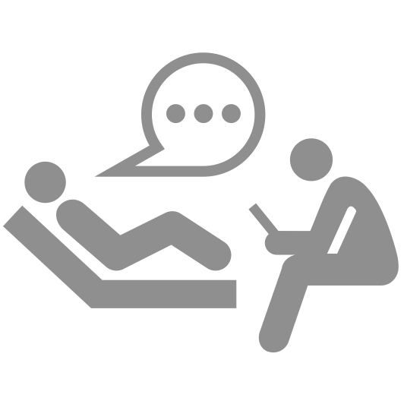
Supporting Resilience
From a behavioral health perspective, disasters are traumatic for those that experience them, and the length and intensity of the disaster, as well as the personal impact to the individual, can increase the degree of adverse impacts a disaster survivor experiences.
The principles of trauma-informed care recognize that extra care should be taken when dealing with disaster survivors because many may have previous trauma or pre-existing conditions; however, even survivors without pre-existing conditions may experience:
- Emergency-induced social problems (e.g., family separation, disruption of social networks, destruction of community structures, increased gender-based violence),
- Emergency-induced distress (e.g., grief, anticipated or nonpathological distress, distress with similar symptoms to mental disorders), or
- Emergency-induced mental disorders (e.g., depression and anxiety disorders, substance misuse, sustained personality changes).
Most disaster survivors successfully recover from disaster-induced adverse impacts with time, but non-clinical actions taken by shelter workers immediately following a disaster can bolster the resilience of the impacted populations and reduce the number of individuals needing longer-term clinical support. These actions include using a community-based approach for non-clinical services in a shelter setting, such as psychological first aid, monitoring and screening for those currently experiencing or at risk of experiencing adverse reactions, stress reduction activities, and referrals for additional psychological, physical, or social services to help meet basic needs. Due to shelters being an inappropriate place for clinical services (e.g., therapy), the only clinical service that may be provided in a shelter is medication services, depending on the availability of resources and qualified staff.

Collaboration and Coordination
If the behavioral health needs of shelter residents exceed the staffing capabilities of a single jurisdiction, or if the incident involves more than one affected jurisdiction, communication and coordination between jurisdictions will be necessary to identify, mobilize, and deliver public, private, and non-governmental behavioral health resources to fulfill those unmet needs.
Having a coordinated mutual aid system for communicating staffing needs and resource requests, as well as having a vetted and up-to-date roster of those trained to provide behavioral health services in a shelter setting (i.e., a behavioral health cadre), can greatly facilitate the process of delivering behavioral health services in multiple shelters and across multiple jurisdictions.
Shelter behavioral health services are also supported by external organizations, such as private providers, faith-based organizations, advocacy groups, community organizations, and other non-profit organizations, that bring a variety of resources and support for services such as spiritual care, child-care, and a multitude of other relevant services or resources to support shelter residents. Additionally, connecting with and utilizing external organizations whose culture and language reflect the community is essential for successfully reaching all impacted populations.
This ConOps provides recommendations for establishing and maintaining such collaborative systems and provides baseline concepts and mechanisms for delivering behavioral health services in a general population shelter. Having this shared regional approach to coordination and service delivery will better enable integration between jurisdictions when mutual aid is needed.
Table of Contents
Executive Summary i
Purpose i
Principles i
1 Introduction 7
1.1 Purpose of the Plan 7
1.2 Audience 7
1.3 Scope 7
1.4 Background 8
1.4.1 ABAHO Region 8
1.5 Situation 10
1.5.1 Impact of Disasters on Behavioral Health 10
1.5.2 Disaster Cycle and Behavioral Health 11
1.5.3 Behavioral Health in a Shelter Environment 13
1.6 Emergency Management in California 14
1.6.1 Standardized Emergency Management System 14
1.6.2 Medical and Health Area Coordination Program 15
1.6.3 Regional Disaster Medical Health Coordination Program 16
1.6.4 Emergency Management Mutual Aid 17
1.6.5 ABAHO Behavioral Health Advisory Committee 17
2 Preparedness 18
2.1 Cadre Development 18
2.1.1 Cadre Credentialing 20
2.1.2 Cadre Member Sources 22
2.1.3 Cadre Cultural Diversity 23
2.1.4 Vetting Cadre Members 24
2.2 External AGency Coordination 24
3 Activation 26
3.1 ConOps Activation Triggers 26
3.2 Public and Private Sector Coordination 26
3.2.1 Mutual Aid Request Considerations 26
3.2.2 County and Regional Mutual Aid Activation 27
3.2.3 Public/Private Sector and Non-Governmental Activation 28
3.3 Integration with the American Red Cross 29
3.3.1 Determining Shelter Management 30
4 Mobilization 31
4.1 Staff Requirements for Service Delivery 31
4.1.1 Service Delivery Overview 31
4.1.2 Behavioral Health Staffing Positions 32
4.1.3 Sample Organizational Charts 33
4.2 Staff Deployment Procedures 35
4.2.1 Staff Notification 35
4.2.2 Tracking and Management of Deployed Staff 36
4.2.3 Staff Briefings 37
4.3 Site Layout 38
4.3.1 Behavioral Health Shelter Components 38
4.3.2 Accessibility 39
5 Operations 40
5.1 Service Delivery 40
5.1.1 Provision of Behavioral Health Care Goals 40
5.1.2 Function-Based Service Delivery Roles 40
5.1.3 Layers of Assessment 41
5.1.4 Population-Specific Service Delivery Considerations 42
5.2 Service Delivery Tools 44
5.2.1 Psychological First Aid 44
5.2.2 Screening and Assessment Tools 45
5.3 Information Management 45
5.3.1 Situation Reporting 46
5.3.2 Shelter Data Collection 47
5.4 Messaging for Shelter Residents 48
5.4.1 Incorporating Behavioral Health into Public Messaging 48
6 Demobilization 51
6.1 Staff Demobilization 51
6.2 After-Action Reporting 51
6.3 Shelter Demobilization 52
6.3.1 Shelter Demobilization Challenges 52
6.3.2 Service Referrals Upon Demobilization 53
6.4 Funding and Reimbursements 53
6.4.1 State and Federal Disaster Financial Assistance 53
6.4.2 Reimbursement for Provision of Mutual Aid and Assistance 55
7 Acronyms 57
8 Glossary 59
9 References 61
10 Appendices 64
10.1 Job Action Sheets / Mission Sets 64
10.2 Activity Log (ICS 214) 70
10.3 Shelter Data Collection Form 72
10.4 Sample Behavioral Health Messaging for Shelter Residents, 73

- Introduction
  - Purpose of the Plan
The purpose of this ConOps is to facilitate coordinated and effective disaster behavioral health operations in a general population shelter in response to an anticipated or realized natural or man-made disaster. Effective disaster behavioral health operations require staff that are specifically trained to operate in a shelter environment, and as such, this ConOps will frequently refer to an assemblage of trained and credentialed staff as a behavioral health cadre.
This ConOps is intended to:
- Define preparedness activities for behavioral health cadre management and training;
- Outline behavioral health capabilities, resources, and services;
- Formalize notification, communication, and information-sharing processes;
- Define roles and responsibilities within adaptable staffing structures; and
- Provide tools, templates, and job aids to support plan implementation.
  - Audience
This document is applicable to behavioral health professionals from governmental, non-governmental, and private sector organizations that may be requested to provide assistance or conduct operations in a general population shelter within the thirteen local health jurisdictions of the Association of Bay Area Health Officials (ABAHO), as well as relevant emergency management stakeholders involved in coordinating disaster behavioral health response efforts.
  - Scope
This document outlines the structure, procedures, and provision of disaster behavioral health services in a general population shelter. The focus of this document is primarily on county-managed shelters, but the concepts and strategies are also applicable for integration with other shelter management types (e.g., American Red Cross-managed shelters).
While some content may be applicable to other types of disaster behavioral health staff deployments, such as for a Local Assistance Center or Family Assistance Center, the content of the ConOps is specifically designed for use in a general population shelter.
  - Background

ABAHO Region
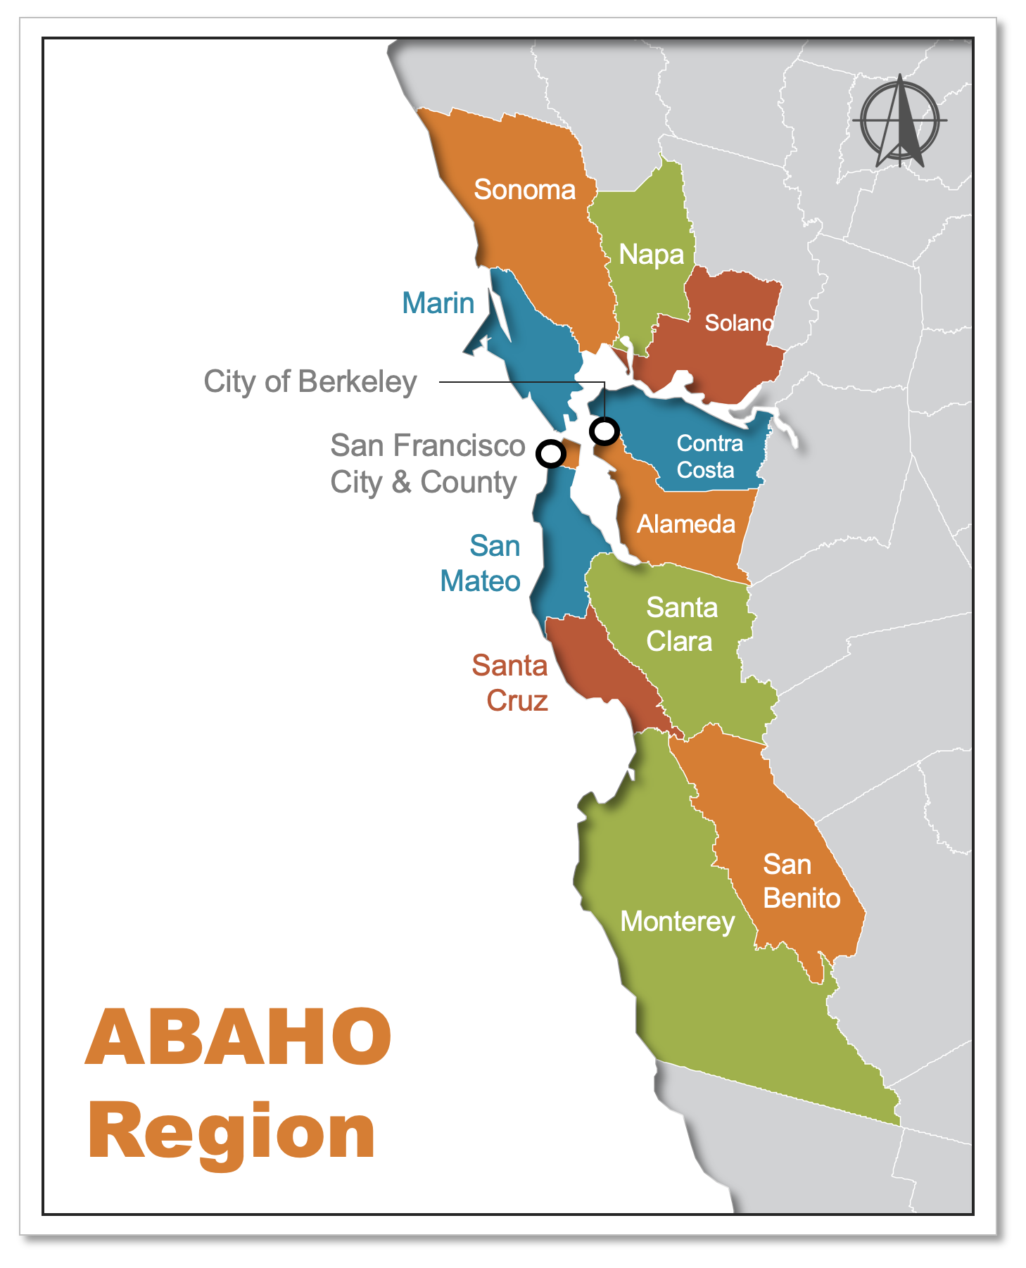
The ABAHO region consists of thirteen local health jurisdictions in the San Francisco Bay Area in Northern California and is currently estimated to house over 8 million residents. While this number represents estimates for the number of people who live within the ABAHO region, it does not account for the significant influx of workers during the day who commute from counties outside the San Francisco Bay Area. A large-scale disaster that occurs during work hours and prohibits individuals from returning to their counties of residence may increase the number of individuals needing shelter within the ABAHO region.
Figure 1: ABAHO Region Map

Regional Profile
Jurisdictions within the ABAHO region are also composed of diverse populations with varied socioeconomic status, urban or rural geographies, and language and cultural backgrounds.
Certain jurisdictions may also be more susceptible to certain disasters than others, though the most common risks include fire, flooding, earthquakes, and mass casualties.
The following table highlights some of the predominant demographic characteristics of the ABAHO jurisdictions that may contribute to the scope of disaster behavioral health needs within those jurisdictions.
Table 1: ABAHO Region Population Considerations
Jurisdiction | Population | Non-English Threshold Languages, | Medium Income ($) | Persons in Poverty (%) | Urban Housing Units (%)
Alameda County | 1,666,753 | - Spanish  - Chinese  - Vietnamese | $92,574 | 9.0% | 99.6%
City of Berkeley | 121,643 | - N/A | $80,912 | 20.0% | 100%
Contra Costa County | 1,150,215 | - Spanish | $93,712 | 7.8% | 99.2%
Marin County | 259,666 | - Spanish | $110,217 | 6.6% | 91.5%
Monterey County | 435,594 | - Spanish | $66,676 | 13.3% | 87.4%
Napa County | 139,417 | - Spanish | $84,753 | 8.8% | 82.5%
San Benito County | 61,537 | - Spanish | $81,977 | 8.6% | 72.4%
San Francisco City and County | 883,305 | - Spanish  - Chinese  - Vietnamese | $104,552 | 10.1% | 99.9%
San Mateo County | 769,545 | - Spanish  - Chinese  - Tagalog | $113,776 | 6.8% | 97.8%
Santa Clara County | 1,937,570 | - Spanish  - Chinese  - Tagalog  - Vietnamese | $116,257 | 7.9% | 98.8%
Santa Cruz County | 46,511 | - Spanish | $78,041 | 12.2% | 98.8%
Solano County | 446,610 | - Spanish  - Tagalog | $77,609 | 7.9% | 96.0%
Sonoma County | 499,942 | - Spanish | $76,753 | 9.9% | 84.1%
  - Situation

Impact of Disasters on Behavioral Health
Disasters affect the behavioral health of those who experience them, and no one experiences a disaster untouched. The American Medical Association states:
“Most people who experience a disaster, whether as a victim or a responder, will have some type of psychological, physical, cognitive, and/or emotional response to the event. Most reactions are normal responses to severely abnormal circumstances.”
Stress, grief, shock, confusion, disorientation, anger, and anguish are normal reactions and are not to be pathologized. Most individuals will experience a normal recovery. However, individuals who experience disasters are all affected differently, and personal factors such as prior trauma, pre-existing conditions, cultural or ethnic background, access to behavioral health care and resources, and access to a social support network can all contribute to the degree of psychological impact on an individual. As a result of variation in an individual’s risk factors (e.g., duration of exposure, threat to life, loss of life, loss of family members, personal factors), behavioral health problems can manifest in various ways. The most common include:
- Transitory distress, a normal grief and stress response following an abnormal event;
- Worsening of pre-existing conditions (e.g., severe emotional distress in children, serious mental illness in adults, substance use disorders); and
- Acute or long-term mental health disorders resulting from the disaster (e.g., anxiety, depression, Post-Traumatic Stress Disorder).

Longer-Term Impacts on Behavioral Health
In most cases, general population shelters are only open in the days and weeks following a disaster. Therefore, shelter residents will primarily be experiencing transitory distress and the aggravation of pre-existing conditions. In the months that follow the disaster, acute and long-term mental health disorders can begin to manifest for those impacted by the event. Evidence suggests that between 30 and 40 percent of disaster survivors develop a new psychological disorder. Acute phase reactions and disorders occur between one and three months following the disaster and are often self-limiting. In contrast, long-term phase disorders last for over three months and require assistance from mental health professionals. The road to recovery from a disaster is long, and behavioral health should be addressed at each stage of the disaster cycle to mitigate the effects of disasters on individuals, households, and communities.

Disaster Cycle and Behavioral Health
The stages of the disaster cycle are depicted in the figure below, and behavioral health objectives for each stage are described in the following sections.
Mitigation
Figure 2: Disaster Cycle and Behavioral Health

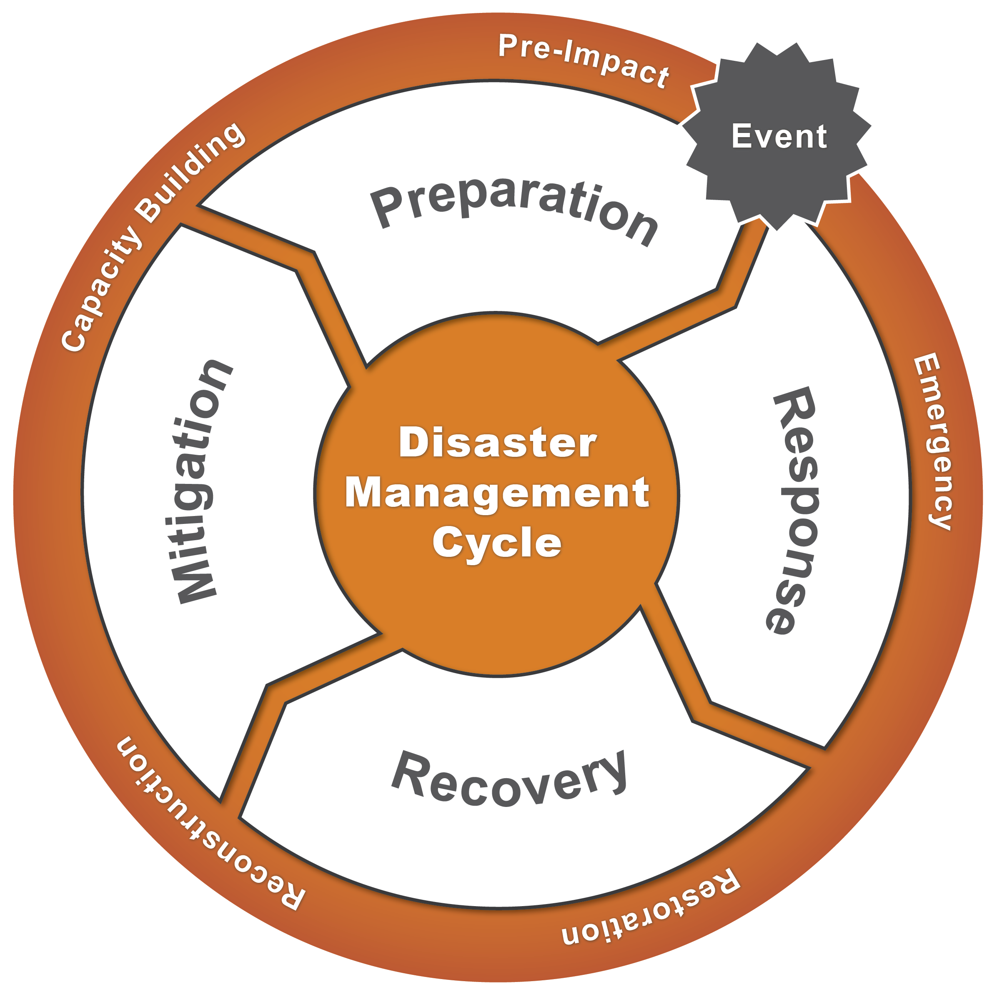
Disaster mitigation refers to acts taken to lessen the severity or intensity of disaster impacts. In a mental/behavioral health context, mitigation refers to actions that support individual and community resilience and have the potential to reduce the need for disaster mental/behavioral health interventions.
Behavioral health objectives for the mitigation phase include:
- Improve community resilience by promoting psychological first aid training in the community and in schools.
- Improve responder and shelter staff resilience by promoting trainings on developing personal resilience/coping plans.
- Integrate coping strategies into household preparedness education to normalize expected reactions to a disaster experience.
Preparedness
Disaster preparedness includes developing and exercising plans and procedures before a disaster in order to increase readiness to mobilize and deliver response and recovery services and resources during and after a disaster.
Behavioral health objectives for the preparedness phase include:
- Recruit and train a behavioral health cadre for disaster behavioral health service delivery and how to operate in post-disaster environments, such as general population shelters.
- Plan among county staff, the behavioral health cadre, and external partners on the steps for triggering, mobilizing, and managing behavioral health services in a shelter, as per this ConOps.
- Work with external partners to develop relationships, document contact information, and coordinate and collaborate on roles and responsibilities.
Response
Disaster response includes actions taken during or immediately following a disaster, such as activities to save lives, protect property and the environment, and meet basic human needs. Disaster behavioral health response helps impacted individuals return to their pre-disaster level of functioning as quickly as possible.
Behavioral health objectives for the response phase include:
- Provide support services to assist survivors with coping with the stress of the disaster, reconnect individuals with their mental health or substance abuse services, and begin surveillance for longer-term behavioral health needs.
  - Note: Clinical services such as formal assessments and therapy are not a part of behavioral health services during the response phase.
Recovery
Disaster recovery includes actions taken to repair and rebuild homes, businesses, and infrastructure; restore health and social services; and help individuals, households, and communities rebuild their lives and increase resilience to withstand future disasters.
Behavioral health objectives for the recovery phase include:
- Implement and support interventions and services to help foster connections and rebuild a sense of community, continue interventions for wellness and education, assess and connect to clinical services, and increase clinical capacity.
- Coordinate across entities to map a behavioral health recovery plan and apply for, and utilize, government and private funding/resources.

Behavioral Health in a Shelter Environment

Shelter Overview
Disaster shelters play an important role in the response and recovery of a disaster by providing secure, temporary places to live for survivors who have left or lost their usual accommodations due to a disaster. Typical shelters include plastic sheets and cots housed in prefabricated units, tents, or public community buildings and are often plagued by overcrowding, limited resources, and delays in aid.
Providing behavioral health in a disaster setting, particularly a shelter, is vastly different than providing services in a clinical setting. Behavioral health shelter workers will primarily be supporting normal behavioral functioning and helping to decrease stress for shelter residents. Behavioral health staff will be involved in a range of activities, including:
- Supporting shelter staff to carry out duties;
- Providing information and referrals;
- Supporting general population residents’ mental health through a stressful event;
- Developing behavioral health support communications; and
- Conducting individual or group psychoeducation activities for shelter residents.
“[We transformed] ourselves in 90 minutes from a traditional ‘County Mental Health’ role focusing on chronic disease management and an insurance oriented, treatment engagement model to a more ‘pure’ population health, trauma-focused, community wide crisis response.”
- Napa County
Key Operational Concepts to Support Resilience
The following key operational concepts and principles form the foundation of behavioral health service delivery in a shelter environment with a focus on building resilience and mitigating future adverse reactions. These principles guide the delivery of services to build and reinforce resilience in the shelter and to support long-term recovery:
- The typical reactions that occur after a disaster such as shock, grief, anger, and sadness are normal.
- Traditional clinical interventions (e.g., formal assessments, counseling, therapy) should not be used to intervene nor disrupt the natural healing process.
- Anyone needing clinical services will receive a referral instead of therapy. If the shelter is large, a clinic may be mobilized to provide acute needs assessment and prescriptions only.
- Most shelter residents’ psychosocial needs are basic and driven by survival issues (e.g., shelter, food, water, safety, medical care, clothing). Behavioral health staff will need to interface with and support general shelter staff to support residents’ basic needs.
- The behavioral health services provided are intended to help the individual cope with the new situation, reduce initial distress, and foster short and long-term adaptive functioning and resilience.
- Observed behavioral health issues in the shelter should inform the broader behavioral health assessment for the impacted community’s short to long-term recovery needs.

Disaster behavioral health response is not therapy. No type of therapy will occur in the shelter.
  - Emergency Management in California

Standardized Emergency Management System
The Standardized Emergency Management System (SEMS) is the backbone of California’s emergency response system and provides the structure for an efficient and coordinated response during a disaster. SEMS utilizes concepts of the Incident Command System, Operational Areas, multi-agency coordination, and mutual aid agreements.
There are five SEMS organizational levels, including field, local government, operational area, region, and state. An Operational Area consists of a county and all political subdivisions within the county area, while a region consists of two or more Operational Areas designed for mutual aid support. There are six Mutual Aid Regions established in California, and the ABAHO jurisdictions fall within the Coastal Region (Region II). The following figure indicates the hierarchy of the five SEMS organizational levels with oversight from the federal Health and Human Services Agency (ESF-8).
Figure 3: Mental and Behavioral Health Organization Levels
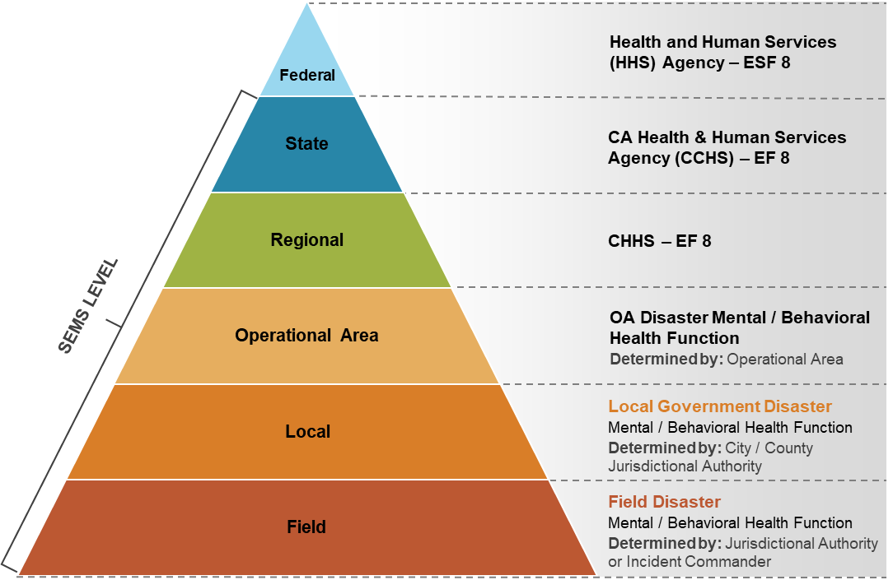

Medical and Health Area Coordination Program
The Medical and Health Operational Area Coordination (MHOAC) Program includes representation from public health, environmental health, emergency medical services (EMS), and mental and behavioral health departments/agencies. The Program’s primary purpose is to oversee and coordinate seventeen specific functions in all disaster medical and health plans, policies, procedures, and operations within its Operational Area.
The MHOAC functions most associated with mental/behavioral health include:
- Assessment of immediate medical needs.
- Coordination of disaster medical and health resources.
- Provision or coordination of mental/behavioral health services.
- Provision of medical and health public information and protective action recommendations.
The designated lead and single point of contact for the MHOAC Program is the Medical and Health Area Coordinator (also frequently referred to as “the MHOAC” or the “MHOAC Position”). To designate this position within each Operational Area, the Health and Safety Code authorizes the county health officer and local EMS administrator to jointly act as the MHOAC Position or to appoint another individual to fulfill the responsibilities.
For the purposes of the Behavioral Health ConOps, the MHOAC Program is the coordinating body responsible for receiving mental and behavioral health resource requests from within its Operational Area during and immediately following a disaster. The MHOAC lead is also responsible for aggregating those Operational Area requests and determining if additional mutual aid is needed from outside the Operational Area.

Regional Disaster Medical Health Coordination Program
The MHOAC Program liaises closely with the Regional Disaster Medical Health Coordination (RDMHC) Program to secure mutual aid support when the Operational Area is unable to meet needs internally for mental/behavioral health needs in general population shelter(s).
The RDMHC Program is responsible for the monitoring and acquisition of medical and health resources during emergencies and is authorized to make and respond to requests for mutual aid from the MHOAC Program. Each Mutual Aid Region will have an RDMHC Program that will provide support and coordination to affected Operational Areas during emergencies.
The Regional Disaster Medical and Health Specialist (RDMHS) is part of the RDMHC Program and directly supports regional preparedness, response, recovery, and mitigation activities. The RDMHS coordinates disaster information, as well as medical and health mutual aid and assistance within the Mutual Aid Region or in support of other affected Mutual Aid Region(s).

Emergency Management Mutual Aid
The State of California Emergency Management Mutual Aid Plan outlines the appropriate steps for providing emergency management personnel and technical specialists to support disaster operations. Jurisdictions forward their requests for mutual aid through their Operational Area, and the Operational Area acts as a coordination point between jurisdictions and the California Governor’s Office of Emergency Services (Cal OES) regions. Cal OES regional offices or Regional Emergency Operations Centers (REOCs), if activated, will act as the coordination point for mutual aid among Operational Areas within their jurisdictions. At the State level, the Cal OES State Operations Center (SOC) will coordinate mutual aid among Cal OES regions.

ABAHO Behavioral Health Advisory Committee
The ABAHO Behavioral Health Advisory Committee (“Advisory Committee”) supports the region in developing and coordinating general standardization for service delivery, preparedness, and volunteer management. The Advisory Committee is comprised of at least one point of contact from each member jurisdiction and representation from contracted agencies and external partners. The primary functions of the committee are:
- Oversee the utilization and maintenance of the ConOps.
- Coordinate training across the region.
- Manage common systems and procedures for the behavioral health cadre.
- Identify areas for system and practice improvements.
- Oversee the development of the mutual aid document signed by each member jurisdiction.
During a disaster operation, the Advisory Committee can provide coordination and oversight support as needed.
Attachment A provides a comprehensive worksheet developed by the U.S. Department of Health and Human Services on the formation and management of a Disaster Behavioral Health Coalition. This worksheet details success criteria, recruitment strategies, and key activities across preparedness, response, and recovery.
- Preparedness
  - Cadre Development
A common cadre development system across the region facilitates the ease of staffing shelters, providing mutual aid, and delivering consistent services. The guidance outlined below provides a foundation for consistency across the ABAHO region while still being adaptable for local preferences and environments.
The ABAHO region should maintain the following:
- A roster of behavioral health professionals (county staff and volunteers), including their professional credentials, specialties, and language and cultural competence capabilities.
- A required set of trainings that all cadre members should take either prior to or as just-in-time training before deploying to a disaster.
  - National Child Traumatic Stress Network:
    - Psychological First Aid
    - Skills for Psychological Recovery
  - American Red Cross:
    - Shelter Fundamentals
    - Disaster Mental Health Introduction and Fundamentals
    - Psychological First Aid
  - Federal Emergency Management Agency (FEMA):
    - National Incident Management System (NIMS) and Incident Command System (ICS) (i.e., ICS-100.c, IS-700.b)
- Regular outreach and communication channels with cadre members to maintain their awareness of protocols and procedures and to update their credentials and capabilities within the roster.
- Regular training and exercises, including refresher training on previously taught concepts (e.g., requiring core trainings to be repeated every three years), to increase cadre competency and familiarity with providing behavioral health services in a shelter setting.

Behavioral Health Supplemental and Specialization Training
In addition to the core behavioral health trainings outlined previously, there are a number of supplemental and specialization trainings that behavioral health cadre members can take to further their knowledge and skills. Cadre members who have an interest or professional background in a disaster behavioral health focus area should pursue additional training in those areas. Examples of disaster specializations include clergy or faith-based, substance abuse, populations with special needs, military, bereavement, severe and persistent mental illness, early childhood populations, child/adolescent populations, adult populations, geriatric populations, and culturally or ethnically diverse populations.
Examples of supplemental and specialization trainings include:
- Substance Abuse and Mental Health Services Agency:
  - Crisis Counseling Assistance and Training Program in-person and/or online trainings
- International Critical Incident Stress Foundation:
  - Assisting Individuals in Crisis
  - Assisting Individuals in Crisis and Group Crisis Intervention
  - Spiritual and Psychological First Aid
- American Red Cross:
  - Fundamentals in Disaster Spiritual Care
- The Salvation Army:
  - Emergency Disaster Services: Emotional and Spiritual Care
San Francisco County has a strong cadre of volunteers comprised of experienced individuals with previous deployment experience. To sustain this cadre, San Francisco County shifted their focus from recruiting new volunteers to keeping their current cadre active through more frequent trainings and small-scale deployments.
- San Francisco County

Behavioral Health Supervisor Training
Behavioral health cadre members who have the credentials and deployment experience to serve as behavioral health supervisors during deployment should consider additional training in expanded ICS concepts and any areas of disaster specialization they may have. Core trainings can include:
- FEMA:
  - Online expanded ICS/NIMS training (i.e., ICS-200.c, IS-800.c)
  - Classroom-based advanced ICS training (i.e., ICS-300, ICS-400)
  - Online expanded disaster trainings (i.e., IS-240: Leadership and Influence, IS-244: Developing and Managing Volunteers)

Cadre Credentialing
Behavioral health cadre members may be comprised of licensed professionals, paraprofessionals, and non-licensed volunteers with the proper training. In the ABAHO region, licensed staff and staff with graduate degrees working on their license (listed in the table below) are eligible to work in a shelter setting. However, depending on the size of the incident and the availability of licensed behavioral health professionals, staff without a license may be used to assist with basic activities to bolster a shelter’s behavioral health team. The level of credentialing that cadre members possess will determine the degree of services that they can provide.

Licensed Behavioral Health Professionals
Licensed professionals and paraprofessionals should be requested and assigned to positions according to their expertise. If a combination of licensed and non-licensed staff is used, licensed staff will typically serve in supervisory roles and carry out activities that require a professional license (e.g., assessments). The following table defines different professional personnel titles and the types of responsibilities appropriate for an individual with that licensure in a general population shelter.
Table 2: Types of Licensed Behavioral Health Personnel
PROFESSIONAL TITLE | RESPONSIBILITIES
Licensed Clinical Social Workers | Psychosocial assessment, crisis counseling, care coordination.
Licensed Professional Clinical Counselor | Psychosocial assessment, crisis counseling, care coordination.
Licensed Marriage and Family Therapist | Psychosocial assessment, crisis counseling, care coordination.
Credentialed School Counselors, School Social Workers, and School Psychologists | Psychosocial assessment, crisis counseling, care coordination.
Licensed Psychologist | Psychosocial assessment, crisis counseling, care coordination.
Licensed Psychiatric Technicians | Medication monitoring, administration.
Certified Psychiatric Registered Nurse | Assessment (physical and behavioral/emotional), medication management, monitoring, crisis counseling, care coordination.
Psychiatrist | Assessment, care coordination, prescription orders.
Certified Drug and Alcohol Counselors | Disaster survivor/response staff education on the impact of disasters on addiction and recovery.
Registered Associate | Various behavioral health services while under supervision (can include Psychological Assistants, Associate Clinical Social Workers, Associate Marriage and Family Therapists, and Associate Professional Clinical Counselors).

Non-Licensed Behavioral Health Cadre Members
Regardless of licensure, therapy and clinical interventions are not suitable for shelter environments. As such, non-licensed professionals with the appropriate training can be excellent additions to behavioral health shelter teams to assist with basic activities when licensed staff are limited. Behavioral health shelter workers without a license are typically comprised of non-profit or non-governmental agency volunteers with training in psychological first aid and shelter operations.
Non-licensed behavioral health cadre members’ responsibilities can include:
- Conducting basic screening.
- Delivering psychological first aid.
- Coordinating wellness activities.
- Providing referrals (e.g., to licensed shelter workers for immediate needs, to external professionals for longer-term needs).

Disaster Spiritual Care Professionals
Disaster Spiritual Care professionals are another integral component of the behavioral health cadre that typically fall into two categories:
- Professional Board-Certified Chaplain
- Endorsed Disaster Spiritual Care Provider
Both types of Disaster Spiritual Care professionals must be previously vetted and trained by their affiliated organization. Board-Certified Chaplains can be sourced from various disciplines (e.g., law enforcement, fire, military, hospital, mental health), while Endorsed Disaster Spiritual Care Providers are primarily community faith leaders.
In addition to the basic training courses outlined in the previous section, Disaster Spiritual Care professionals should also attend specialized training courses related to disaster spiritual and emotional care.

Cadre Member Sources
The following list includes some of the most common sources of behavioral health cadre members but is not intended to be an exhaustive list.
Local and State Agencies:
- County behavioral health agency staff and contract providers.
- County departments of health and public health.
- Local certified chaplains through local law enforcement, fire departments, and hospitals.
- Local law enforcement/fire department behavioral health and/or peer support personnel.
- State-to-state behavioral health resources available through the Emergency Management Assistance Compact.
Voluntary Organizations:
- Licensed behavioral health care providers on the Disaster Healthcare Volunteers registry maintained by the Emergency Medical Services Authority (EMSA).
  - These personnel resources are typically requested by local Medical Reserve Corps and/or Disaster Healthcare Volunteer Coordinators.
- American Red Cross disaster mental health volunteers.
- Local Voluntary/Community Organizations Active in Disaster (VOAD/COAD).
- Community Emergency Response Team (CERT) volunteers.
U.S. Department of Health and Human Services:
- Mental Health Teams comprised of U.S. Public Health Service commissioned officers that provide behavioral health services, including PsySTART rapid triage.
- Applied Public Health Teams, a component of the U.S. Public Health Service, that can assist with disaster behavioral services and disaster behavioral health epidemiology.
U.S. Centers for Disease Control and Prevention:
- Community Assessment for Public Health Emergency Response (CASPER) Program: disaster behavioral health risk and epidemiology.
- Center for Preparedness and Response: specialized, focused population assessments in addition to CASPER.

Cadre Cultural Diversity
The cadre should reflect the diversity of the communities being served, which requires outreach and relationship development with various organizations that may not typically be a part of the public mental health system. To ensure diversity of the cadre beyond county behavioral health professionals, other types of professionals in health, social services, education, and faith-based fields assist in the delivery of culturally competent services, connecting with community residents, and providing interpretation.
Having cultural diversity is essential to facilitate shelter residents’ adaptation to shelter residency and to promote healthy coping with the incident. Simple adjustments such as familiar food and cultural activities as appropriate can be included as a part of shelter activities.

Vetting Cadre Members
Outside of county employees and contractors, cadre members will need to be vetted before being added to the ABAHO disaster behavioral health cadre roster. Considerations for vetting cadre members include:
- Requiring an unencumbered professional license/registration validated through the State of California Department of Consumer Affairs online registry;
- Requiring the specific disaster behavioral health/shelter training certifications outlined in Section 2.1: Cadre Development;
- Requiring a background check; and
- Requesting a letter of recommendation from a current or previous supervisor.
Cadre members will always be expected to act in a manner consistent with their professional status and licensure and to adhere to the ethics of their profession.
  - External AGency Coordination
External agencies can be valuable resources for general population shelters. Connecting with these agencies prior to a disaster to build partnerships and coordinate pre-disaster planning is the most effective way to integrate their services. Communicating and planning with external agencies before a disaster strikes is key to providing county agencies with enough time to properly vet the agencies and to gain a thorough understanding of their capabilities.
Once integrated and vetted, external agencies can provide a wealth of resources and support, including but not limited to:
- Spiritual Care providers can be an integral part of providing emotional support during shelter operations. Multiple established organizations have trained and experienced Spiritual Care Teams that can deploy to a shelter. Some examples include the American Red Cross, Presbyterian Disaster Services, and The Salvation Army. Other resources are law enforcement chaplains and Disaster Medical Assistance Team (DMAT) team ministers.
- Partners such as those belonging to the California Voluntary Organizations Active in Disaster (VOADs) can provide specialized services and support staff. Utilizing local and regional VOADs is also an excellent way to match the language and cultural competencies of shelter workers to that of shelter residents.
- Professional groups, such as local psychological and psychiatric associations, can also assist with mental and behavioral health support. In past disasters, such organization have been willing to offer pro bono or reduced-price consultations for those referred to their offices from shelters. Coordinating with these professional groups can bolster the capacity and efficacy of mental and behavioral health referrals made in the shelter setting, especially for populations unable to pay the full price for professional services after returning home from the shelter.

Governmental Partners
County behavioral health agencies should also coordinate with other governmental partners, such as medical/public health agencies and emergency and recovery managers. Integrating with medical/public health divisions is often easy due to behavioral health departments being structured within an overarching public health structure, but behavioral health staff should also integrate with medical/health staff in the shelter setting to improve efficiencies and to ensure that behavioral health and medical health occupy non-competing spaces within the shelter.
Behavioral health agencies should also build relationships with emergency and recovery management and send representation to Emergency Operations Centers. Coordinating with emergency management will help to ensure that behavioral health is integrated early and throughout the response and recovery process. Public Information Officers (PIOs) at Emergency Operation Centers can also assist with disseminating trauma-informed messaging about the safety and availability of general population shelters.
- Activation
  - ConOps Activation Triggers
This ConOps is activated with the occurrence of a traumatic natural or manmade disaster that results in the establishment of a general population shelter within the ABAHO region.
  - Public and Private Sector Coordination
When a natural or man-made disaster overwhelms the capacity of the local jurisdiction(s) to staff general population shelters with disaster behavioral health workers, requests for mutual aid and support resources from neighboring jurisdictions, private providers, and community-based organizations should be made.

Mutual Aid Request Considerations
Requests for behavioral health staff should prioritize members of the behavioral health cadre that have been previously credentialed and trained. In the absence of sufficient available staff from the behavioral health cadre, counties may need to look outside of the cadre roster for staff resource requests.
Many types of mental/behavioral health and spiritual care staff may be utilized to provide disaster behavioral health services in a shelter. The State of California has not yet established training and credentialing standards for disaster behavioral health workers; however, requesting certain professional qualifications for shelter workers is a nationwide best practice.
Recommendations include:
- The requesting jurisdiction should specify:
  - Qualifications of the behavioral health and/or spiritual care staff they are requesting.
  - Population-specific information to determine the best-suited staff to serve the impacted population (e.g., language skills, cultural competencies, expertise with access and functional need, chronically mental ill, homeless, LGBTQ, or medically vulnerable populations).
- The assisting jurisdiction should match the qualifications, language skills, cultural competencies, and expertise requests of the requesting county with that of their staff offered for assistance.
- Beyond professional qualifications and population-specific considerations, staff resource requests should prioritize behavioral health professionals with:
  - Previous disaster experience.
  - Shelter-specific training.
- For out-of-county staff resource requests, the requesting and assisting jurisdictions should consider a minimum 7-day deployment, including 5 working days and 2 days for travel.

County and Regional Mutual Aid Activation
Disaster behavioral health resource requests will be coordinated through the MHOAC and RDMHC programs (see Section 1.6.1. Standardized Emergency Management System for more information on California emergency management entities). Refer to the State of California Mental/Behavioral Disaster Framework, the California Public Health and Medical Emergency Operations Manual, and the State of California Emergency Management Mutual Aid Plan for additional detailed information on mutual aid notification procedures, resource requesting, and resource management.

Steps for County Mutual Aid Activation
The type and scale of the disaster will dictate the types of coordination necessary. The following steps outline the typical activation and initial coordination for establishing county behavioral health resources in a general population shelter.
- For incidents that can be managed without regional resources, the impacted county’s MHOAC liaison will contact the county’s Behavioral Health Director to activate staffing shelters for service delivery. For larger incidents requiring regional resources, the impacted county’s MHOAC liaison will contact the RDMHS to coordinate mutual aid.
- The impacted county’s Behavioral Health Director or designee will assign behavioral health command positions for each shelter.
- In the absence of an online website/portal, an ABAHO region live spreadsheet/form will be kept in an accessible online location for all county behavioral health leadership to view in real time to monitor open and filled requests. The spreadsheet will detail:
  - Number of open positions and missions
  - Credentials needed for each position
  - Calendar with open shifts for which to sign up
  - Any just-in-time training being offered
  - Logistics for signing up and reporting to assignment
- Behavioral health command staff will utilize the online portal/spreadsheet/form to access and request available behavioral health cadre members that match the needs of the shelter.
- Behavioral health command positions will coordinate behavioral health conference calls with the provider community and key partners for staffing services and provide situational awareness for short-term and long-term planning.

Public/Private Sector and Non-Governmental Activation
As outlined in the Preparedness section, activation of the plans and services with the external partners will executed. Previously vetted organizations and their affiliates should be registered as members of the behavioral health cadre with their specializations and current credentials provided. Behavioral health command staff can access this information and notify the cadre members in the same manner that county behavioral health staff are notified. Stakeholders that can provide services or resources as part of the behavioral health cadre include:
- Faith-based organizations, including those who have spiritual care teams.
- Private providers for behavioral health or substance abuse.
- 2-1-1 for coordinating referrals.
- Organizations and groups reflective of cultural and ethnic groups in the community.
External organizations that arrive on-scene at the shelter without being previously vetted and cleared will not be allowed to interact with shelter residents and will be asked to leave the shelter area until they undergo a credentialing process by county and shelter behavioral health leadership.
  - Integration with the American Red Cross
The American Red Cross often serves in a primary shelter management role, or in a supporting role for county-managed shelters, to provide supplementary community resources in addition to what the county can provide.
Pre-disaster coordination with the American Red Cross is necessary to outline expectations and capabilities and to smoothly incorporate both American Red Cross services and county services into shelter operations. Additionally, many California counties have existing memorandums of understanding (MOUs) in place with the American Red Cross for sheltering.
The American Red Cross maintains a roster of disaster volunteers that can provide various services and functions in a shelter setting, including:
- Disaster Mental Health workers that can:
  - Assist with the emotional needs of shelter residents and shelter workers.
  - Identify individuals who need additional support.
  - Provide short-term disaster mental health interventions, including:
    - Enhanced Psychological First Aid,
    - Psychoeducation,
    - Referrals to local mental health resources,
    - Community resilience training,
    - Advocacy,
    - Crisis intervention, and
    - Condolence support.
  - Refer individuals to local resources as necessary, including providing financial assistance for mental health needs (e.g., co-payment for therapy).
- Disaster Health Service workers that can support the mental/behavioral health of the shelter population by meeting their basic needs (e.g., medications, durable medical equipment, eyeglasses, financial assistance for health needs).
- Disaster Spiritual Care teams that can provide spiritual and emotional support from associate and board-certified Chaplains.
- Disability integration workers that can assist with the needs of and provide advocacy support for individuals with access and functional needs, including those with a disability.
- Reunification workers that can assist with meeting the short-term reunification needs of those directly impacted by disaster through providing human and technological resources to connect individuals from inside the disaster-affected area to outside the affected area.
  - The American Red Cross Safe and Well website provides a mechanism for individuals to register themselves as safe and to allow individuals to search the registration list for their loved ones.
- Caseworkers that can assist shelter residents through the American Red Cross shelter transition program to help shelter residents transition to permanent housing.
- Integrated Care Condolence teams that can assist with condolence emotional support and provide resource and financial support for families of the missing or deceased.
Other services the American Red Cross can provide include access to a 24/7 national support hotline for shelter staff, short-term financial assistance for basic needs, and arranging for outside providers to conduct substance abuse support meetings.

Determining Shelter Management
Shelter management may transition from being American Red Cross-managed, county-managed, or privately managed depending on available resources and staffing.
- For American Red Cross-managed shelters, the American Red Cross will coordinate with host counties to integrate personnel and processes. Information the American Red Cross will need from the supporting county includes:
  - Number of available county staff members.
  - Anticipated availability of county staff (e.g., only on weekdays/weekends).
  - Point of contact for the county’s Crisis Stabilization Unit.
- For county-managed shelters, the American Red Cross point of contact will require the following information to provide effective support:
  - Type of services needed.
  - Number of volunteers needed.
  - Whether there is there a supervisor on site, and if not, who should be called.
  - If medical/health operations are present in the shelter for medication procurement.
- Mobilization
  - Staff Requirements for Service Delivery
After the impacted county has requested mutual aid and the agency responsible for shelter management has been determined, management staff should consider the number of needed behavioral health staff and the service delivery structure into which they should be organized. Advanced planning for resource typing and response team development will assist in mobilizing the correct resources and staff for the incident at hand.

Service Delivery Overview
Behavioral health staff will perform various functions depending on the specifics of the shelter environment and their own professional qualifications. The following four types of behavioral health assistance should occur at general population shelters:
- Monitoring and Needs Surveillance: Conducting needs surveillance of the shelter population, observing how residents are managing their activities of daily living (e.g., sleeping, eating, socializing), identifying mental health concerns, and connecting individuals with appropriate sources of care. This is the primary function of behavioral health staff in a general population shelter.
- Mental Health Support: Providing coping strategies and emotional comfort for distress related to the disaster experience and displacement (e.g., psychological first aid, crisis counseling, social services); and managing acute mental health problems in the short-term until resolution or formal mental health care can be arranged.
- Wellness Activities: In cooperation with shelter management and other services, set-up wellness activities to provide stress relief and social interaction.
- Providing Referrals: Triaging patients with specific psychiatric needs to external sources of care (e.g., inpatient psychiatric hospitalization, specialized treatment programs such as methadone maintenance programs).
Depending on the specific needs of the shelter and on the availability of appropriately licensed staff and resources, the following types of behavioral health assistance may occur:
- Care Coordination: Reconnecting those with serious mental illness and co-occurring substance abuse with their current case manager or with a new or interim case manager.
- Psychiatric Assessment: Stabilizing pre-existing or new post-disaster psychiatric conditions.
- Medication Administration: Starting, continuing, or restarting psychotropic medications for pre-existing or post-disaster psychiatric conditions.
Behavioral health staff may also perform functions not directly related to service delivery, such as providing consultation to shelter leadership on talking points in morning briefings related to behavioral health issues or people with serious mental illness.

Behavioral Health Staffing Positions
The following table provides a list of positions and task forces for delivering the above-mentioned services and reflects which positions require a license. For small to medium shelters, one person may cover more than one position.
Table 3: Behavioral Health Staffing Positions
Position Title | Description | License
Behavioral Health Associate | Assists with behavioral health services such as Surveillance and Monitoring, Wellness Activities, and Referrals. Works under the direction of the Group Lead or Behavioral Health Specialist. | Not Required
Behavioral Health Communications Lead | Manages all internal communication related to team management, mutual aid requests, and resident messaging. All media inquiries are turned over to the Public Information Officer or the Joint Information Center. | Not Required
Behavioral Health Group Lead | Leads the team of behavioral health professionals and services in the shelter; sets the operational plan and manages implementation; and coordinates with shelter management. | Required
Behavioral Health Mission Support Team | Assists shelters with setting up behavioral health services according to size/environment. Serves as an organizing and oversight team for all shelters within a geographic area. Key responsibilities: logistics for equipment, transportation, space; safety; and staff support for training and orientation. | At least one team member required
Behavioral Health Specialist | Provides behavioral health services according to the size and needs of the shelter. Able to deliver Surveillance and Monitoring, Wellness Activities, Referrals, Mental Health Support, and Care Coordination. | Required
Behavioral Health Specialist Lead | Leads a small team to carry out a specific behavioral health service. | Required
Integrated Behavioral Health Task Force | For medium to large shelters, the task force is comprised of behavioral health, medical health, shelter leadership, and external partners to plan and coordinate services in the shelter. Team is comprised of a Behavioral Health Group Lead and Behavioral Health Specialist Leads. | Required
Mental Health Pharmacy | Psychiatrist available to provide maintenance medication. | Required
Program Associate | Assists the Behavioral Health Lead to create operational plans, collect data, create reports, and perform administrative tasks. For smaller shelters, takes on the roles of the Mission Support Team with assisting with logistics and safety. | Not Required

Sample Organizational Charts
The sample organizational charts listed in this section are suggestions based on shelter size. Adjustments should be made as the needs of the shelter evolve.
Figure 4: Sample Organizational Chart for a Large Shelter (500+ Residents)

Figure 5: Sample Organizational Chart for a Medium Shelter (100-500 Residents)

Figure 6: Sample Organizational Chart for a Small Shelter (>100 Residents)

Staff Ratio Considerations
The specific needs of the shelter and the availability of behavioral health staff will ultimately determine the staff to shelter resident ratio, but shelter management should consider the following staff ratio recommendations:
- One behavioral health staff member is recommended for every 25-50 shelter residents.
- One behavioral health supervisor is recommended for every 7 behavioral health staff members.
Most volunteers will work one to two shifts; however, county employees assigned to a specific shelter may work extended periods.
  - Staff Deployment Procedures

Staff Notification
Behavioral health cadre members must always wait for notification and assignment before deploying. Self-deployment is never allowed.

General Notification
Once the potential need for behavioral health staff deployment has been identified, a “general notification” message should be sent to county behavioral health staff and/or members of the behavioral health cadre as determined by the location and expected staffing needs of the incident. These messages should be sent via an alert system capable of sending notifications by email, phone, and text message, and include information regarding the incident, including the affected population; potential resource needs; and the expected duration of the event to the extent known.

Role-Specific Notification
Based on staffing needs determined by shelter behavioral health command positions, requests for specific personnel and/or professional classifications may be requested. Shelter command staff can utilize the online portal/spreadsheet to access current cadre information, including specializations. In the absence of an online portal/spreadsheet, command staff should coordinate with the MHOAC liaison and/or county behavioral health directors to request behavioral health staff with specific credentials and/or specializations.

Tracking and Management of Deployed Staff

Individual Accountability
Following basic Incident Command System principles can ensure the safety and accountability of deployed shelter staff. Each shelter worker maintains the responsibility to adhere to the following principles:
- Check-In: Upon arrival to the designated deployment site, all deployed shelter workers must check-in with their supervisor and any other entities indicated during their assignment briefing.
- Attending Orientation Meetings and Briefings: Deployed shelter workers should attend all orientation meetings and briefings to learn new operational information, locations of facilities and services, the check-in location and time of next briefing, end of shift parameters, appropriate next steps for any triage conducted, contact information for referral services, and any additional necessary information.
- Knowing Your Surroundings: Deployed shelter workers should always maintain a thorough understanding of their surroundings, such as the locations of food, water, medical facilities, bathrooms, supplies, and other resources. This also includes surveying the landscape with an eye for potential hazards and/or unanticipated problems.
- Communication: Shelter workers have an individual responsibility to communicate any safety issues they see or any feelings of being personally unwell to their team leader, supervisor, and/or other appropriate channels. Shelter workers should not continue to work if they do not feel well enough to do so. Proper communication allows shelter management to track the safety and wellbeing of the shelter workers under their care.
- Check-out: All shelter workers must notify their supervisors and follow appropriate protocol when leaving each shift and upon demobilization from the shelter.

Team Accountability
While shelter management staff are responsible for the safety and wellbeing of the shelter workers under their care, the agencies and organizations that the shelter workers belong to also have a responsibility for tracking and maintaining accountability for the deployed staff from their own agency/organization. The following considerations outline best practices for tracking deployed staff and maintaining team accountability.
- Even if a county has not fully activated its Emergency Operations Center at the operational level, a department (e.g., mental/behavioral health) may activate specifically to track deployed mutual aid staff.
- Larger deployments may benefit from implementing a “team lead” structure where managers or staff with deployment experience serve as team leads who track accountability of the colleagues who deploy with them.
  - This structure does not need to follow hierarchies used during normal operations and can be a simple way to encourage team accountability among peers.
- Maintain current emergency contact information for all deployed cadre members and provide their family members with a 24/7 telephone contact number in case there is a family emergency requiring the cadre member to return home.

Staff Briefings
Staff briefings should occur during each stage of deployment: upon pre-deployment notification; at the deployment staging area before travel to the requesting county (if applicable); and upon arrival at the requesting county’s incident staging area (if applicable) and/or on site at the shelter. Staff should be encouraged to remain flexible and adaptable at each briefing.
Pre-Deployment Notification
Held by the Requesting Jurisdiction. Typically held virtually via video- or tele-conference.
Commonly includes:
- Overview of the incident situation (e.g., map and description of affected area, expected number of displaced persons, expected number of shelters);
- What to expect upon deployment (e.g., length of shift, types of meals, sleep accommodations);
- What to bring (e.g., cell phone, identification badge, copy of current, unencumbered clinical license from the State of California Department of Consumer Affairs, state-issued photo identification, any medications, food for special dietary restrictions, appropriate clothing, hygiene essentials);
- Next steps (e.g., email with additional deployment instructions, expected timeframe for official deployment notification);
- Safety tips (e.g., plan on spending at least one night, health impacts of shelter location, hydration, accountability, self-care);
- Behavioral health services tips (e.g., psychological first aid reference materials and videos).
- Contact information for the deployment supervisor and instructions for checking-in upon arrival.
Deployment Staging Area Briefing
Held by the Assisting Jurisdiction. This briefing is held by the assisting agency before staff travel to the requesting county. Depending on the circumstances and number of deploying staff from a single jurisdiction, staff may be asked to report directly to the requesting jurisdiction and receive briefing information via other methods (e.g., conference call, email).
Commonly includes:
- Any situation updates or additional context since the initial notification;
- Expectations for maintaining proper communication channels and accountability with supervisors;
- Emphasis that deployed staff from an assisting county must integrate into current shelter operations to avoid cross-purposes and duplication of effort. The requesting county is the controlling authority for use of emergency medical and public health services within its jurisdiction.
Incident Staging Area Briefing / On Site Briefing
Held by the Requesting Jurisdiction. Depending on the circumstances and resources of the assisting agency, staff may be directed to report directly to the shelter instead of to an incident staging area.
Commonly includes:
- A shelter-specific situation report, including services available in the shelter;
- Assignment of roles and responsibilities (e.g., Job Action Sheets);
- Instruction on the use of an Activity Log (ICS 214) to track daily activities and how to submit completed forms (e.g., email, hard copy);
- An overview of facility operations, client flow, and shift change and demobilization procedures.
- A printed referral list for each shelter worker.
  - Site Layout

Behavioral Health Shelter Components
The variation of site types, client needs, and the duration of the incident will dictate the physical requirements and configuration of behavioral health operations within a shelter. A map of the shelter, that indicates the location of behavioral health services, should be displayed in multiple locations throughout the shelter for staff and shelter residents to reference.
When setting up shelter operations, the following areas should be considered; however, it may be determined that not all areas are required or feasible.
- Registration Desk: Behavioral health staff trained on signs/symptoms of distress will assist general shelter staff and/or medical/health staff at the registration desk to observe incoming shelter residents and inconspicuously assess behavioral health needs.
- Mental/Behavioral Health Table: While most behavioral health staff will be roaming the shelter performing monitoring and surveillance, a table should be staffed for shelter residents who may seek out services or information.
- Private Conference Area: A room or cordoned off area should be designated for providing behavioral health staff and shelter residents with a private place for conversation if desired.
- Staff Area: There may be a designated staff area/room separate from resident areas to provide staff with a respite area, a place to store personal belongings, and a location for staff discussions/briefings.
- Supply Area: An area should be designated where all supplies coming into the shelter will be secured and maintained.

Accessibility
In parallel with general shelter operations, behavioral health operations should account for residents with limited English proficiency and access and functional needs by providing:
- Multilingual staff and signage;
- Communication assistance and services to complete registration processes and forms.
- Assistance for individuals with cognitive and intellectual needs.
- Access to medication to maintain mental health functions.
- Auxiliary aids and services necessary to ensure effective communication (e.g., screen readers).
Behavioral health staff should also be mindful of the concerns that may arise from co-locating undocumented immigrants with state and federal agencies. Considerations include providing reassurance of amnesty from deportation at the shelter and limiting the use of law enforcement/homeland security logos and symbols.
See Appendix 10.4 Sample Behavioral Health Messaging for Shelter Residents for a sample public messaging flyer communicating the safety of shelters for undocumented populations.
- Operations
The following section outlines the operational activities and services provided in a shelter. The shelter will be comprised of diverse individuals and households from different language and cultural backgrounds, orientations, and demographics. Staff and volunteers should be reflective of the community, and service delivery should occur in a manner that is respectful of the varied cultures of shelter residents whenever possible. All shelter workers should always abide by the ethics for their profession when deployed in a shelter environment.
  - Service Delivery

Provision of Behavioral Health Care Goals
The purpose of shelter behavioral health services may vary depending on the type and scale of the disaster; however, certain goals and objectives tend to remain consistent across most disasters. The three overarching goals of care include:
- Provide behavioral health support services to assist shelter residents in coping and adapting to their current environment.
- Identify those who may need additional care and make appropriate referrals.
- Inform short to long-term planning for behavioral health needs and system capacity building.

Function-Based Service Delivery Roles
To meet the needs of shelter residents, behavioral health staff will need to fill various service delivery roles. Depending on staff to shelter resident ratios and the experience level of available staff members, behavioral health staff may perform one or more roles. The types of function-based service delivery roles are listed below.
- Monitoring and Surveillance
- Wellness Activities
- Referrals
- Communication and Messaging
- Clinical Services
Details about each position is included in Appendix 10.1: Job Action Sheets / Mission Sets.

Layers of Assessment
Early identification and intervention are key to assisting individuals in adapting to the overwhelming circumstances of a disaster and to mitigate or address significant mental health issues. The approach to assessment is layered, as depicted in the following figure.
Figure 7: Layers of Assessment
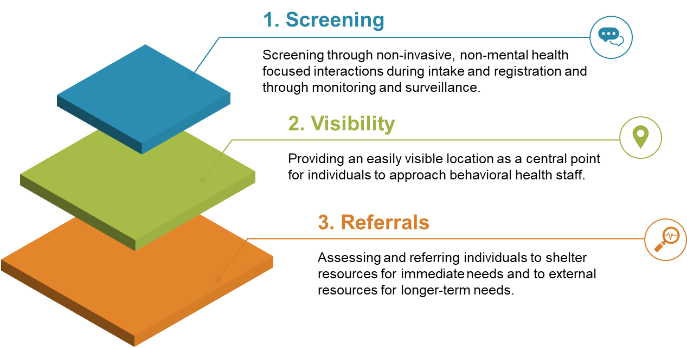

Screening
As individuals or families enter the shelter, they will be processed through registration. A member of behavioral health staff or properly trained non-behavioral health shelter staff will be present at the main shelter registration desk to assist with initial behavioral health screening in conjunction with medical/health staff screening for medical needs.
Screening is also a main function of the monitoring and surveillance activity provided as behavioral staff walk around the shelter engaging with individuals and families. Additional details are provided in Section 4.1.1: Service Delivery Overview.

Visibility within the Shelter
The shelter will also have a location that is labeled “Mental Health and Wellness” to allow those who want information or to speak with someone to have an obvious place to seek assistance. Although this is not the main strategy for engagement, it does provide a central point for those who are interested.

Assessment and Referrals
Additional assessment will occur as a referral from the screening process and as a result of the findings from monitoring and surveillance. The purpose of assessment is to identify shelter residents’ needs and connect them with shelter resources for immediate needs and external resources for longer-term needs, such as therapy and treatment. Triage for medication maintenance is also an important component for identifying individuals who may not have access to their psychiatric medications. Individual therapy and prescribing new medications are not a part of the in-shelter services. For information regarding prescription management, see the ABAHO Med/Health Toolkit Tool: Prescription Management.

Population-Specific Service Delivery Considerations
Considerations for certain populations are described in the table below. For individuals who are not well suited to a shelter environment due to behavioral problems or special needs, the ARC does have the limited ability to place residents in hotels.
Table 4: Population-Specific Considerations
Population | Considerations
Access and Functional Needs | - Coordinate with state and local Functional Assessment Service Teams (FAST) that can assist shelter workers in distinguishing between people who need assistance in maintaining their health, medical stability, and mobility, from those who need medical help.  - FAST members typically have experience in mental health disabilities, hearing and visual disabilities, developmental disabilities, physical disabilities, cognitive disabilities, aging services, and substance abuse.
Children | - Utilize experienced, credentialed non-governmental organizations to provide childcare services.  - Follow all legal reporting and recording guidelines for an unaccompanied minor or separated child (e.g., completing shelter forms, registering with the National Center for Missing and Exploited Children) and connect with the appropriate agencies.  - Follow all legal and ethical guidelines for reporting child abuse to the appropriate authorities (e.g., law enforcement, Child Protective Services).
Cultural Considerations | - Coordinate with staff or volunteers from the community on how to bring cultural norms into the shelter.  - Ensure services are delivered in a manner reflective of the various cultures of the shelter population.
Elderly | - Follow all legal and ethical guidelines for reporting elder abuse to the appropriate authorities (e.g., law enforcement, Adult Protective Services).
Limited-English Proficiency | - Provide interpretation services, preferably by staff or volunteers from the same community.  - All messages and materials should be provided in the first and second most prominent language in the shelter. Additional translations should be provided depending on the language requirements of the shelter population.
Residents with Additional Stressors | - Monitoring and surveillance should prioritize those residents who may have additional stressors.  - Follow all legal and ethical guidelines for reporting domestic violence to the appropriate authorities (e.g., law enforcement).
Serious Mental Illness | - If a shelter resident with serious mental illness is identified, staff should maintain the resident’s stability and medication and connect with case manager (if applicable).  - Individuals having a psychiatric crisis may need a 5150/5585 assessment and hold (i.e., an Involuntary Psychiatric Hold).  - Only peace officers and county-designated staff with the specific certification can legally conduct a 5150/5585 assessment and hold.  - The behavioral health supervisor should determine in advance who in the shelter has the authority and socialize that information with shelter staff.  - 5150/5585 holds must be transferred to a designated facility (i.e., a facility licensed or certified as a mental health treatment facility or hospital, such as a licensed psychiatric hospital, a licensed psychiatric health facility, or a certified crisis stabilization unit).
Substance Abuse | - Coordinate 12-Step meetings on-site or provide assistance with attending meetings close to the shelter.  - Provide substance abuse counseling support for medium to large shelters.  - Coordinate with community services to maintain stability of services if possible.
Undocumented Individuals | - Send staff to provide Psychological First Aid to individuals congregating outside of shelters.  - Conduct outreach to community leaders to reassure the public that shelters are safe places.  - Disseminate the Safe Shelter: Protections for Residents with Undocumented Status public messaging flyer in the shelter and in areas where displaced individuals are congregating. See Appendix 10.4: Sample Behavioral Health Messaging for Shelter Residents.
  - Service Delivery Tools

Psychological First Aid
Disaster behavioral health workers should all be familiar with and trained on the use of Psychological First Aid (PFA). PFA is designed to be used as a job aid for shelter workers to use while interacting with disaster survivors to provide basic behavioral health support.
The core elements of PFA include:
- Contact and engagement
- Safety and comfort
- Information-gathering regarding current needs and concerns
- Practical assistance
- Connection with social supports
- Information on coping
- Linkage to collaborative services
- Respecting limitations
Behavioral health cadre members should remember that PFA is not intended to be professional counseling, a clinical/psychiatric intervention, or a psychological debriefing. Shelter residents should not be asked to analyze what happened or be pressured to share their story. Instead, PFA should provide support and practical assistance.

Screening and Assessment Tools
A wide variety of screening and assessment tools are available to the ABAHO region. The table below provides a menu of options with details about the capabilities of each for jurisdictions to consider. The table is not all inclusive and is not intended to dictate the specific tools that a jurisdiction should use.
Table 5: Screening Tools
Screening Tools | Description
PsySTART Rapid Mental Health Triage System | - Assists with individual identification and population surveillance and decision support for broader behavioral health services.  - Used to identify mental health risk and route clients to appropriate assistance.  - Can be administered by non-mental health professionals.  - Fee for use.
Kessler Screening Scale for Psychological Distress (K-6) | - Identifies the presence of broad mental health problems that are severe enough to cause moderate to severe impairment in social or occupational functioning.  - Average completion time is 5 minutes.
Red Cross 3 Rs | - Combines the following three elements for one quick assessment:  - Concerning Reactions  - Risk Factors  - Resilience
  - Information Management
Information management, including collection, recordkeeping, and information sharing procedures, is an important part of the continued improvement and success of both shelter operations and for maintaining the continuum of care for residents following shelter demobilization. Timely, accurate, accessible, and consistent information-gathering and dissemination will help to create a common operating picture during a disaster event and will help inform longer term behavioral health needs in the community. Additionally, sharing pertinent information with efficiency is vital to emergency response support, coordination, and decision-making.

Situation Reporting
To ensure consistent and accurate information is collected and disseminated, information gathering procedures should include situation reporting, which commonly takes the form of a standard template referred to as a Situation Report (SitRep). As outlined in the California Public Health and Medical Emergency Operations Manual, the behavioral health agency executive should send timely information to the local MHOAC liaison, who will then prepare a Medical and Health SitRep to send to the relevant coordinating bodies as outlined in the figure below.
Figure 8: Information Flow during Emergency System Activation
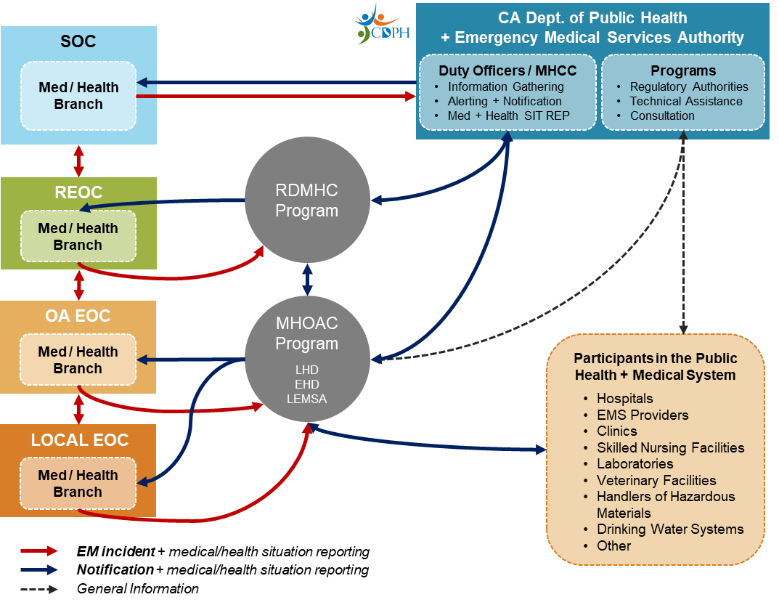
These reports should be sent following incident recognition, once per operational period, following significate changes, and/or by the request of regional or state coordinating bodies. Included below are examples of mental/behavioral health information that might be gathered.
- Population based assessments of mental/behavioral health impacts and needs.
- High-risk groups or populations of special concern.
- Potential for psychological harm (acute and long-term).
- Behavioral/mental health needs of responders.
- Capabilities for providing disaster mental health and emergency behavioral health care (e.g., personnel, medications), including:
  - Capacity among licensed health care facilities (e.g., psychiatric bed counts, pediatric psychiatric bed counts)
  - Number of available licensed responders and non-licensed individuals trained in psychological first aid, psychological triage, and other response skills.
- Disaster mental/behavioral health support being provided at shelters and other facilities.
- Behavioral service delivery.
- Resources requested.

Shelter Data Collection
At the shelter level, behavioral health-related activities must also be recorded to inform staffing and resources at the operational level. Shelter command staff can use collected data to request additional staff and resources if shelter resident needs are being unmet or to demobilize/reallocate staff and resources if they are no longer needed. Additionally, information collected at each general population shelter about the types and prevalence of needed services should also directly tie into longer-term behavioral health service planning.

Activity Logs (ICS 214)
Individual behavioral health shelter workers must maintain a log of activities that they perform during each shift, including start and end times for that shift. The standard form most commonly used is FEMA’s Activity Log (ICS 214) form, which is provided in Appendix 10.2: Activity Log (ICS 214).
These forms are an essential part of deployment operations and provide written records for:
- Finance and administration staff to use for payment and reimbursement.
- Legal records to limit staff liability in the event of an adverse outcome (e.g., resident dies by suicide).
- Individual documentation for behavioral health services requested and provided to inform shelter-wide reports.
Shelter workers should be instructed during their orientation meeting/briefing on the appropriate process for submitting their ICS 214 forms to the appropriate personnel (e.g., taking a photo and emailing to designated staff).

Shelter Data Collection Form
It is also important for shelter and behavioral health management to be able to accurately gauge the overall need for behavioral health services within a shelter and the rate at which behavioral health workers can meet those needs. To assist with tracking and documenting the behavioral health services provided during each shift, a Behavioral Health Shelter Data Collection form is provided in Appendix 10.3: Shelter Data Collection Form.
This tool is intended to be completed by a shelter behavioral health supervisor, at a recommended frequency of once per shift, and reported to Medical/Health Branch leadership to inform staffing and resources at the operational level. This tool is intended to be integrated with American Red Cross data collection forms and the ABAHO PHP Med/Health Toolkit Shelter Data Collection Form. The behavioral health supervisor for each shift can consolidate the information documented on each behavioral health shelter worker’s Activity Log (ICS 214) in order to have a single report compiling the summary data for that shift.
  - Messaging for Shelter Residents

Incorporating Behavioral Health into Public Messaging
During operations, behavioral health staff should work closely with communications staff (e.g., public information officers and/or external affairs) to broadcast messaging that is sensitive to a stressed community and incorporates the principles of trauma-informed care. If staffing resources allow, a Behavioral Health Communications Lead position can be established to assist with ensuring that all outgoing messaging is filtered through a behavioral health lens and that behavioral health information is included.
Prior to and during shelter operations, messaging to the public and shelter residents should begin to ease the transition to the shelter environment and encourage those who are apprehensive about entering a shelter that it is a safe place. Typical shelter notifications to the public include the status of the emergency, the jurisdictions’ actions being taken, the location and time the shelter(s) will be available to the public, and the types of services that will be available at the shelter location(s).
In addition to ensuring the logistical information is shared in a trauma-informed manner, behavioral health staff can also assist communications personnel/public information officers with adding in language to communicate the safety of staying in a shelter and the availability of crisis counseling via 2-1-1 phone lines.

Principles of Trauma and Crisis-Informed Messaging
There are six principles that should be recognized and utilized when building trauma-informed messaging for general population shelter clients to prevent re-traumatization:
- Promote feelings of physical and psychological safety.
- Build trust by remaining transparent throughout.
- Establish a supportive environment among trauma survivors for healing.
- Eliminate harmful power dynamics and elevate partnerships.
- Focus positively on personal autonomy, resilience, and ability.
- Recognize and appropriately address historical trauma and biases.
Other considerations include:
- Uphold privacy and confidentiality in shelter staff-client interactions.
- Express empathy in all formal and informal communication to demonstrate that shelter staff are working in the best interests of the affected populations.
- Use simple concise messages. In a crisis affected people take in, process, and act on information differently than they would during non-crisis times. When people are exposed to extreme stress, such as being forced to evacuate their homes, information may be misheard, misremembered, or misinterpreted due to stress.
- Emphasize choices and actions. Give people something to do to help themselves or others and to quell feelings of hopelessness and helplessness. Those in the shelter may feel that their personal autonomy has been stripped away, thus giving options and trusting their decision-making capacity can help to build this back.
- Ensure accessibility of communication for varied audiences:
  - Are multilingual translations of the messaging needed?
  - Are braille transcriptions or assistive listening devices required?
  - Are there multiple modalities that the messaging can be distributed through?
- Evaluate the effectiveness of messaging. If shelter residents are not utilizing the behavioral health services being offered, collect feedback in order to better tailor the shelter’s outreach plan. Make necessary changes in a timely manner in order to best serve shelter residents.
Additional supporting details and templates are provided in Appendix 10.4 Sample Behavioral Health Messaging for Shelter Residents.
- Demobilization
  - Staff Demobilization
Behavioral health cadre members may be released from duty before the shelter is closed or just prior to shelter demobilization. No cadre member should demobilize before shelter command staff affirms that they are being released from duties. The following staff demobilization activities should occur:
- Conduct staff debriefings to identify lessons learned, memorialize best practices, and note any concerns.
- Ensure that all equipment temporarily loaned to staff/volunteers is returned.
- Provide staff/volunteers with information on self-care and returning to work, Critical Incident Stress Management resources/services, and Employee Assistance Programs.
- Administer a Post-Deployment Assessment to staff/volunteers prior to exiting the shelter.
- Notify the assisting jurisdictions/agencies of the demobilization of their staff and instruct the demobilizing staff to check-in with their home agencies upon their return.
  - After-Action Reporting
Development of an After-Action Report (AAR) following disaster operations is an important way to identify areas of improvement for jurisdictions and the region as a whole. Jurisdictions also have a legal responsibility to develop and submit an AAR to the California Emergency Management Agency (Cal EMA) when certain conditions are met. The State of California Mental-Behavioral Health Disaster Framework states that:
“EMS regulations under Title IX, Division 2, Chapter 1, Section 2450(a) requires any federal, state, or local jurisdiction proclaiming or responding to a Local Emergency for which the governor has declared a State of Emergency or State of War Emergency shall complete and transmit an AAR to Cal EMA within 90 days of the close of the emergency period.”
The AARs must also include a plan of action for implementing improvements. Cal EMA will also complete an AAR in conjunction with the State and local government agencies within 120 days of an emergency proclamation.
  - Shelter Demobilization
County leadership will continually assess the need for maintaining general population shelters following a natural or manmade disaster. Once the determination is made that a shelter is no longer needed, command staff will initiate demobilization procedures. From a behavioral health perspective, shelter workers should be cognizant of the challenges of demobilization for shelter residents and the importance of maintaining the continuum of care.

Shelter Demobilization Challenges
Planning for demobilization should occur throughout shelter operations, and behavioral health shelter workers should continuously be identifying those who may experience challenges upon the closing of the shelter. Shelter residents may need additional service referrals and connection to temporary/interim housing resources.

Temporary/Interim Housing Needs
Returning to pre-disaster accommodations following shelter demobilization can be especially difficult for individuals experiencing homelessness.
- Many areas previously inhabited by the homeless may not be suitable for return because of the disaster, and any previous belongings were likely lost as a result of the disaster or due to the inability to bring them into the shelter. Communities that provided support are likely to have been dispersed, and community-based organizations and advocacy groups may not yet have reopened.
- Additionally, shelter residents who previously had housing accommodations may now find themselves experiencing homelessness due to the destruction caused by the disaster and without the financial capacity to find new housing. This can contribute to even higher numbers of shelter residents with no place to go once a shelter closes. Significant numbers of shelter residents will likely need assistance being placed in temporary/interim housing, and historically there has been insufficient providers to meet the demand.
Pre-disaster planning and coordination with external partners is needed to preemptively address the need to find interim/temporary housing for vulnerable populations and to mitigate anticipated demobilization challenges. Community-based organizations that typically provide direct and ongoing services to vulnerable populations during steady-state times will likely be in the best position to support the recovery of those populations. Additionally, the American Red Cross may be able to assist with connecting shelter residents to temporary/interim housing and other disaster recovery services.

Service Referrals Upon Demobilization
Case management services are intended to provide shelter residents with access to resources they need to recover from a disaster and may vary for each individual or family. To ensure placement with a capable agency or case manager, behavioral health staff will leverage findings from completed intake forms and basic screening results.
Long-term case management will be coordinated with local organizations and agencies, and available resources will be communicated to county residents. Similarly to the identification of shelter residents who need temporary/interim housing, shelter residents who need service referrals should be receiving those referrals from behavioral health shelter workers throughout the duration of the shelter and not only at demobilization.
  - Funding and Reimbursements

State and Federal Disaster Financial Assistance
Funding and reimbursement for disaster shelter operations may occur from regional, state, and federal sources. Jurisdictions should refer to the California Public Health and Medical Emergency Operations Manual for detailed information on disaster financial assistance. Example sources of disaster financial assistance include:
- State assistance (e.g., California Disaster Assistance Act following a gubernatorial State of Emergency declaration).
- Federal assistance (e.g., FEMA Public Assistance Program and Crisis Counseling Assistance and Training Program following a Presidential declaration).
All labor costs, including regular employee and temporary hire labor hours, rates of pay, duty assignment, and work location, must be documented, along with a breakdown of fringe benefits for regular and overtime rates, to receive disaster assistance funding. To assist with accurate recordkeeping and accounting, all deployed behavioral health staff should maintain daily Activity Log (ICS 214) forms and submit to the appropriate agency representatives so that accurate labor costs can be recorded.

FEMA Crisis Counseling Program
Following a presidentially declared disaster, the Crisis Counseling Assistance and Training Program (CCP) is activated in accordance with Section 416 of the Stafford Act:
“The President is authorized to provide professional counseling services, including financial assistance to State or local agencies or private mental health organizations to provide such services or training of disaster workers, to victims of major disasters in order to relieve mental health problems caused or aggravated by such major disaster or its aftermath.”
Funded by FEMA and administered through an interagency agreement with the U.S. Health and Human Services Agency and the Substance Abuse and Mental Health Services Administration (SAMHSA), the CCP provides supplemental disaster relief funding to states, U.S. territories, and federally recognized tribes. For states to receive funding, the governor or his/her authorized representative must begin assessing the need for crisis counseling services within 10 days of the major disaster declaration and submit documentation asserting that the need cannot be met by state and local resources alone.
The CCP funds the following primary and secondary service types:
- Individual crisis counseling
- Group crisis counseling
- Basic supportive or educational contact
- Public education
- Community networking and support
- Assessment, referral, and resource linkage
- Development and distribution of educational materials
- Media and public service announcements
The CCP uses two grant programs to provide disaster relief funding, the Immediate Services Program (ISP) and the Regular Services Program (RSP). The ISP application must be submitted within 14 days of the disaster declaration rate, and the RSP application must be submitted within 60 days of the disaster declaration data. Detailed instructions for applying for both ISP and RSP can be found at SAMHSA’s Disaster Technical Assistance portal.

Reimbursement for Provision of Mutual Aid and Assistance
ABAHO region jurisdictions have various local, regional, and state mutual assistance agreements in place, and jurisdictions are beholden to the legal requirements outlined in the specific agreement that is utilized (e.g., California Mutual Aid Region II Intra-Region Cooperative Agreement for Emergency Medical and Health Disaster Assistance). If mutual aid is delivered without a MOU in place, a post-disaster MOU can be developed if the jurisdictions can retroactively reach agreement on the terms, though this method is not recommended due to the potential for restricted reimbursement.
Some general considerations for “Requesting” and “Assisting” counties are included below; however, jurisdictions remain responsible for confirming specific funding and reimbursement requirements as outlined in all executed legal agreements.

Considerations for the Requesting County
Requesting counties should consider the following:
- Accurate records of assistance requests should be kept by both Requesting and Assisting counties.
- County behavioral health agencies must route resource requests through their MHOAC or they risk not being reimbursed.
- The requesting county is generally financially responsible for the costs of personnel, equipment, and supplies that the assisting county provides at its request.
- Requesting counties must send post-deployment records for each deployed staff member under their care to their home jurisdiction. Post-deployment records for each deployed staff member should include, at minimum:
  - Mission/deployment name and location
  - Date(s) of service
  - Number of hours of service
  - Role assigned during deployment
  - Incident Personnel Performance Rating form (ICS 225)

Considerations for the Assisting County
Assisting counties should consider the following:
- Accurate records of assistance requests should be kept by both Requesting and Assisting counties.
- Agencies are generally beholden to their own policies on overtime pay for civil servants.
- Post-deployment records for each deployed staff member should be received from the Requesting county and properly stored.
- Within the legally required period of time, the assisting county should provide the precise accounting of its actual costs for the incident to the requesting county, and the requesting county should pay the billing within the legally specified time frame.
- Acronyms
Acronym | Description
AAR | After-Action Report
ABAHO | The Association of Bay Area Health Officials
BH | Behavioral Health
Cal EMA | California Emergency Management Agency
Cal OES | California Governor's Office of Emergency Services
California DCA | California Department of Consumer Affairs
CASPER | Community Assessment for Public Health Emergency Response
CCP | Crisis Counseling Assistance and Training Program
CERT | Community Emergency Response Team
ConOps | Concept of Operations
DMAT | Disaster Medical Assistance Team
DSC | Disaster Spiritual Care
EMMA | Emergency Management Mutual Aid
EMS | Emergency Medical Services
EMSA | Emergency Medical Services Authority
FAST | Functional Assessment Service Teams
FEMA | Federal Emergency Management Agency
ICISF | International Critical Incident Stress Foundation
ICS | Incident Command System
IS | Independent Study
ISP | Immediate Services Program
JIC | Joint Information Center
LGBTQ | Lesbian, Gay, Bisexual, Transgender, and Queer or Questioning
MHOAC | Medical and Health Operational Area Coordination
MOU | Memorandum of Understanding
NCTSN | The National Child Traumatic Stress Network
NIMS | National Incident Management System
PFA | Psychological First Aid
PHP | Public Health Preparedness
PsySTART | Psychological Simple Triage and Rapid Treatment
RDMHC | Regional Disaster Medical Health Coordination
REOC | Regional Emergency Operations Center
RSP | Regular Services Program
SAMHSA | Substance Abuse and Mental Health Services Administration
SEMS | Standardized Emergency Management System
SitRep | Situation Report
SOC | State Operations Center
VOAD/COAD | Local Voluntary/Community Organizations Active in Disaster

- Glossary
Term | Definition
5150/5585 Assessment and Hold | An involuntary psychiatric hold; An individual may be detained under the Welfare and Institutions Code Sections 5150 and 5585.50 when, as a result of a mental health disorder, the individual is a danger to others or to self, or is gravely disabled (i.e., unable to provide for one’s basic personal needs or food, clothing and shelter [Section 5008(h)]).
Behavioral Health Cadre | A vetted and up-to-date roster of those trained to provide behavioral health services in a shelter setting.
Crisis Stabilization Unit | Unit deigned to treat the symptoms of mental health emergencies promptly and efficiently.
Disaster Behavioral Health | The provision of mental health, substance abuse, and stress management services to disaster survivors and responders
Disaster Mitigation | Acts taken to lessen the severity or intensity of disaster impacts.
Emergency Management Assistance Compact | A mutual aid agreement between U.S. states and territories allowing all to share resources during disasters.
Emergency Operations Center | A central command and control facility responsible for strategic direction and operational decisions; collecting, gathering, and analyzing data; and managing resource requests.
Family Assistance Center | A reunification and information center for families and victims separated by a disaster.
General Population Shelter | A safe refuge that provides mass care services, such as feeding, case management, and health services, to individuals who are displaced by a threat or hazard.
ICS 214 | An activity log to track daily activities within a general population shelter.
Local Assistance Center | A facility created and overseen by local governments that provides recovery resources and services to those affected by a disaster.
Mutual Aid Region | One of the five SEMS organizational levels that consists of two or more Operational Areas designed for mutual aid support.
Operational Area | One of the five SEMS organizational levels that consists of a county and all political subdivisions within the county area.
Psychiatric Crisis | Any situation in which a person’s actions, feelings, and behaviors are leading to them being a danger to themselves or others.
Separated Child | A minor who has been separated from both parents, or from their previous legal or customary primary caregiver, but not necessary from other relatives.
Transitory Distress | Temporary stress and emotional responses.
Unaccompanied Minor | An un-emancipated child younger than 18 who has been separated from both parents, legal guardians, other relatives and are not being cared for by an adult who, by law or custom, is responsible for doing so.
- References
California Conference of Local Health Officers. (2016). Medical and Health Operational Area Coordination Program Manual. Retrieved from https://www.cdph.ca.gov/Programs/CCLHO/CDPH%20Document%20Library/MedicalandHealthOperationalAreaCoordinationManual.pdf.
California Department of Public Health. (2011). California Public Health and Medical Emergency Operations Manual. Retrieved from https://www.cdph.ca.gov/Programs/EPO/CDPH%20Document%20Library/FinalEOM712011.pdf.
California Department of Public Health. (2018). California Public Health and Medical Emergency Operations Manual - Disaster Behavioral Health. Retrieved from https://emsa.ca.gov/wp-content/uploads/sites/71/2018/11/EOM-Disaster-Behavioral-Health-10-26-2018.pdf.
California Department of Public Health. (2018). California Public Health and Medical Emergency Operations Manual – Resource Typing Guidance Disaster Mental/Behavioral Health and Spiritual Care. Retrieved from https://www.cdph.ca.gov/Programs/EPO/CDPH%20Document%20Library/EOM%20Documents/EOM%20Disaster%20Behavioral%20Health%20Resource%20Typing%20Aides.pdf.
California Emergency Management Agency. (2012). State of California Emergency Management Mutual Aid Plan. Retrieved from https://www.caloes.ca.gov/PlanningPreparednessSite/Documents/09%20EMMA%20Plan%20and%20Annexes,%20November%202012.pdf.
California Health and Human Services Agency. (2012). State of California Mental/Behavioral Health Disaster Framework. Retrieved from http://cdmhc.org/framework.pdf.
Federal Emergency Management Agency. (2016). Crisis Counseling Assistance and Training Program Guidance. CCP Application Toolkit, Version 5.0. Retrieved from https://www.samhsa.gov/sites/default/files/images/fema-ccp-guidance.pdf.
Federal Emergency Management Agency. (n.d.) Activity Log (ICS 214). Retrieved from https://training.fema.gov/emiweb/is/icsresource/assets/ics%20forms/ics%20form%20214,%20activity%20log%20(v3).pdf
Federal Emergency Management Agency. Incident Personnel Performance Rating (ICS 225). Retrieved from https://www.fema.gov/media-library-data/20130726-1922-25045-3333/ics_forms_225.pdf.
Galea, S., Nandi, A. and Vlahov, D. (2005). The Epidemiology of Post-Traumatic Stress Disorder after Disasters, Epidemiologic Reviews, 27(1), 78–91, https://doi.org/10.1093/epirev/mxi003.
Hopper, E. K., Bassuk, E. L., & Olivet, J. (2010). Shelter from the storm: Trauma-informed care in homeless service settings. The Open Health Services and Policy Journal, 3, 80-100).
Math, S. B., Nirmala, M. C., Moirangthem, S., & Kumar, N. C. (2015). Disaster Management: Mental Health Perspective. Indian journal of psychological medicine, 37(3), 261–271. https://doi.org/10.4103/0253-7176.162915.
McFarlane, A. C., Williams, R. (2012). Mental Health Services Required after Disasters: Learning from the Lasting Effects of Disasters. Depression Research and Treatment, Volume 2012. doi:10.1155/2012/970194.
Norris, F. H. (2006). Methods for Disaster Mental Health Research. Guilford Press.
Robert T. Stafford Disaster Relief and Emergency Assistance Act, 42 U.S.C. § 5183 - U.S. Code - Unannotated Title 42. The Public Health and Welfare § 5183. Crisis counseling assistance and training.
San Francisco Health Network Behavioral Health Services. (2019). 5150/5585 Involuntary Detention Manual. Retrieved from https://www.sfdph.org/dph/files/CBHSdocs/Involuntary-Detention-Manual-April-2019.pdf.
State of California Health and Human Services Agency Department of Health Care Services. (2017). Standards for Determining Threshold Languages and Requirements for Section 1557 of the Affordable Care Act. Retrieved from https://www.dhcs.ca.gov/formsandpubs/Documents/MMCDAPLsandPolicyLetters/APL2017/APL17-011.pdf.
Substance Abuse and Mental Health Services Administration. (2013). Disaster Planning Handbook for Behavioral Health Treatment Programs. Retrieved from https://store.samhsa.gov/system/files/sma13-4779.pdf.
Substance Abuse and Mental Health Services Administration. (2014). SAMHSA's Concept of Trauma and Guidance for a Trauma-Informed Approach. Retrieved from https://s3.amazonaws.com/static.nicic.gov/Library/028436.pdf.
U.S. Census Bureau. (2010). Decennial Census Summary File – Housing Units. Retrieved from https://data.census.gov/cedsci/table?q=rural%20vs%20urban&hidePreview=true&tid=DECENNIALSF12010.H2&vintage=2010.
U.S. Census Bureau. Vintage 2018 Population Estimates. Retrieved from https://www.census.gov/quickfacts.
U.S. Department of Health and Human Services Centers for Disease Control and Prevention. (2019). Crisis + Emergency Risk Communication – Psychology of a Crisis. Retrieved from https://emergency.cdc.gov/cerc/ppt/CERC_Psychology_of_a_Crisis.pdf.
U.S. Department of Health and Human Services Centers for Disease Control and Prevention. (n.d.). Coping with a Disaster or Traumatic Event. Retrieved from https://emergency.cdc.gov/coping/pdf/Coping_with_Disaster.pdf.
U.S. Department of Health and Human Services Centers for Disease Control and Prevention. (2019). Helping Children Cope During and After a Disaster: A Resource for Parents and Caregivers. Retrieved from https://www.cdc.gov/childrenindisasters/pdf/children-coping-factsheet-508.pdf.
U.S. Department of Health and Human Services Office of the Assistant Secretary for Preparedness and Response. (n.d.) Disaster Behavioral Health Fact Sheet. Retrieved from https://www.phe.gov/Preparedness/planning/abc/Documents/disaster-behavioral-health.pdf.
U.S. Department of Health and Human Services Office of the Assistant Secretary for Preparedness and Response Division of At-risk Individuals, Behavioral Health, and Community Resilience. (n.d.) Disaster Behavioral Health Coalition Guidance. Retrieved from https://www.phe.gov/Preparedness/planning/abc/Documents/dbh_coalition_
guidance.pdf.
U.S. Department of Health and Human Services Substance Abuse and Mental Health Services Administration. Disaster Technical Assistance Center. Retrieved from https://www.samhsa.gov/dtac.

- Appendices
  - Job Action Sheets / Mission Sets

Purpose
Job Action Sheets / Mission Sets for each service delivery role are included below to outline the function-based service delivery role’s mission, tasks, and reporting guidance documents. There is a single sheet for each of the following service delivery roles:
- Monitoring and Surveillance
- Wellness Activities
- Referrals
- Communication and Messaging
- Clinical Services

Preparation
The Job Action Sheets / Mission Sets may be tailored based on the specific needs of the shelter but are intended to be applicable to most shelter environments.

Distribution
Behavioral health shelter command staff should distribute the Job Action Sheets / Mission Sets to shelter workers based on experience, background, and professional credentialing.

Notes
- If there are no behavioral staff with the appropriate credentials to serve in a particular role (e.g., clinical services), that sheet should not be disseminated.
- Due to shelter size and resource availability, behavioral health shelter workers may need to serve in more than one function-based service delivery role.

Mission
- All shelter residents are provided connection and support to assist them with coping with the stress of the disaster event and shelter environment.
- Shelter residents with multiple stressors or that may be in immediate distress receive support or referrals for more intensive intervention in a timely fashion.
- Ongoing behavioral health services and long-term recovery planning is informed by initial mental health reactions observed in shelters.

Mental / Behavioral Health Personnel

Monitoring and Surveillance

- ICS 214: Activity Log
- Shelter Data Collection Form
- ICS 201: Incident Briefing
- ICS 213: General Message
Reporting Guidance

- ICS 214: Activity Log
- Shelter Data Collection Form
- ICS 201: Incident Briefing
- ICS 213: General Message
Tasks
- Resident Interaction for Screening and Support -- Conduct monitoring and surveillance in an informal manner to ensure residents feel comfortable and that they are not being “analyzed”. Walk around the shelter and surrounding areas (e.g., parking lot) engaging in simple conversations with residents while utilizing screening methods described in this document or of their choice. Consider partnering with other shelter staff to carry out general activities (e.g., delivering water, providing basic information) to make starting conversations more innocuous.
- Deliver psychological first aid as soon as possible for residents exhibiting stress. If the resident has an existing mental health diagnosis and/or is exhibiting a level of distress requiring more formal assessment or treatment, immediately determine whether a referral or even an emergency intervention is needed. For residents with multiple stressors, provide additional assistance including referrals and coordination with shelter staff.
- Coordination with Shelter Team -- Strategize with shelter management on the best method for conducting monitoring and surveillance. Provide instructions to shelter staff on what behaviors, words, and physical symptoms may indicate a resident needs assistance and the process for informing the behavioral health staff.
- Behavioral Health Service Planning – Collect information on the general mental health trends of the shelter population through interaction with the shelter residents to drive the overall behavioral health strategy across the disaster operation.

Mental / Behavioral Health Personnel

Wellness Activites

Mission
- Shelter residents have access to activities they would be interested in that promote stress reduction and maintaining wellness while in a shelter setting.
Reporting Guidance

- ICS 201: Incident Briefing
- ICS 213: General Message
- ICS 214: Activity Log
- Shelter Data Collection Form
- ICS 201: Incident Briefing
- ICS 213: General Message
- ICS 214: Activity Log
- Shelter Data Collection Form
Tasks
- Plan and Design Wellness Activities – Design activities based on information from the monitoring and surveillance activity to understand what interests and talents the residents bring to assist with activities. As a team, enlist a few residents to help plan and possibly carry out activities. Examples include a resident who leads a drum circle or a resident who leads an artistic project. The possibilities are only bound by appropriateness and available resources.
- Oversee Delivery of Activities – Regardless of if the activity is being led by behavioral health staff or a shelter resident, behavioral health staff should be involved at every stage (e.g., review and approve the activity, work with shelter management to set a time and location for the activity, and be present to monitor the activity, at least initially).
- Partner Coordination - Wellness activities can be hosted by external agencies. Each agency should be vetted to ensure they have the correct experience and credentials to carry out the activity. For children and youth, an external agency (e.g., Save the Children) will most likely provide activities and/or support.
- ICS 201: Incident Briefing
- ICS 213: General Message
- ICS 214: Activity Log
- Shelter Data Collection Form
Tasks
- Resource Identification – Most resources will be available through a central repository such as 2-1-1. If a particular resource is unavailable, work with 2-1-1 and other social services agencies to fill any gaps.
  - For behavioral health services, coordinate as a team with the MHOAC and Behavioral Health Advisory team on what community and private resources are available considering local staff and resources may be volunteering at shelters or in other capacities throughout the operation.
  - Consider printing a list of all referral partners to provide to behavioral health shelter workers to facilitate the referral process.
- Referral Process - Each resource will typically have basic instructions for making a referral. Referrals should be tracked per resource type and reported in the larger Shelter Data Collection report.
- ICS 214: Activity Log
- Shelter Data Collection Form
- ICS 201: Incident Briefing
- ICS 213: General Message
Mission
- Shelter residents receive timely and relevant referrals to available shelter resources for immediate needs.
- Shelter residents receive timely and relevant referrals for longer-term needs, such as clinical behavioral health services, and/or assistance with basic needs such as transportation, clothing, or financial assistance.
Reporting Guidance

Mental / Behavioral Health Personnel

Referrals

- ICS 201: Incident Briefing
- ICS 213: General Message
- ICS 214: Activity Log
- Shelter Data Collection Form
Tasks
- Mutual Aid Coordination – Send and organize mutual aid requests in a clear, concise, and consistent manner. Educate staff volunteers on exactly what to expect, where to report, and what to bring with them.
- Behavioral Health Messaging – Coordinate and deliver public messaging to residents and staff by tailoring template messaging. Topics include:
  - Education on coping with the disaster event.
  - Self-care techniques to remain mentally healthy.
  - Encourage those with undocumented status to feel safe entering a shelter.
- Distribute the behavioral health public messaging included in the Behavioral Health ConOps widely. Reference the Communications section for additional detail on how to tailor messages to a population affected by a disaster.

Mental / Behavioral Health Personnel

Communication and Messaging

Reporting Guidance

Mission
- Mutual aid requests and coordination occurs quickly and efficiently.
- Shelter staff are educated on self-care methods to stay well and in good mental health.
- Shelter residents are informed on coping mechanisms to address their disaster-related stress and to assist their children with stress reduction.
- Impacted individuals and households concerned with entering a shelter are informed on the safety of the shelter.

- ICS 201: Incident Briefing
- ICS 213: General Message
- ICS 214: Activity Log
- Shelter Data Collection Form

Mental / Behavioral Health Personnel

Clinical Services

- ICS 214: Activity Log
- Shelter Data Collection Form
- ICS 201: Incident Briefing
- ICS 213: General Message
Mission
- In medium to large shelters, shelter residents can access basic mental health clinical services on site in conjunction with health services.
Reporting Guidance

Section break [PLACEHOLDER – LEAVE IN DRAFT VERSION]
- ICS 201: Incident Briefing
- ICS 213: General Message
- ICS 214: Activity Log
- Shelter Data Collection Form
Tasks
- Clinical or Psychiatric Assessment – Perform formal assessment services on-site to immediately triage significant mental health needs that require medication or clinical services in the immediate term. These services should occur as a referral from the monitoring and surveillance or wellness behavioral health specialists and only be performed by staff with the appropriate licensure.
- Medication Administration – Provide medication for shelter residents who have pre-existing conditions or who are assessed by licensed professionals to need acute medication care. Coordinate with Medical/Health staff for available prescription management services. See the ABAHO PHP Med/Health Toolkit: Prescription Management Tool for more details.
  - Activity Log (ICS 214)

Purpose
The Activity Log (ICS 214) records details of notable activities that occur during a single shelter operational period. These activity logs provide basic incident activity documentation and a reference for any after-action report.

Preparation
An ICS 214 can be initiated and maintained by individuals or teams as it is needed or appropriate. Behavioral health shelter workers should document how relevant incident activities are occurring and progressing or any notable events or communications.

Distribution
Behavioral health shelter command staff should distribute the forms to all shelter workers. Completed ICS 214s are submitted to supervisors, who forward them to the Documentation Unit (if applicable) and the behavioral health shift supervisor. All completed original forms must be given to the Documentation Unit, which maintains a file of all ICS 214s. It is recommended that individuals retain a copy for their own records.

Notes
- The ICS 214 can be printed as a two-sided form.
- Use additional copies as continuation sheets as needed and indicate pagination as used.

Figure 9: Activity Log (ICS 214)
1. Incident Name: |  | 2. Operational Period: Date From: Date To:  Time From: Time To:
3. Name: |  | 4. ICS Position: |  | 5. Home Agency (and Unit):
6. Resources Assigned:
Name |  | ICS Position |  | Home Agency (and Unit)
7. Activity Log:
Date/Time | Notable Activities
8. Prepared by: Name: Position/Title: Signature:
ICS 214, Page __ |  |  | Date/Time:
  - Shelter Data Collection Form
Purpose: This form aggregates the behavioral health-related activities that occur within a shelter once per shift to inform staffing and resources at the operational level and to inform longer-term behavioral health service planning. The Behavioral Health Lead for each shift should submit this form to the appropriate Behavioral Health Agency Executive or designee.
Figure 10: Shelter Data Collection Form
Shelter Data Collection Form
Form Completed by: | Shelter Location:
Shelter Manager Contact Information:
Behavioral Health Agency Executive/Designee Contact Information:
General Shelter Data
Shelter Activation Date: | Number of Residents:
Behavioral Health Services Data
Number of residents engaged: | Children:
 | Adult:
 | 65+:
Number of residents that received PFA:
Number of mental health issues recorded: | General distress (overwhelmed, disoriented, agitated):
 | Sadness:
 | Serious and/or persistent mental illness:
Number of residents referred for additional mental health assessment:
Other notes:
  - Sample Behavioral Health Messaging for Shelter Residents,

Purpose
Many aspects of behavioral health wellness messaging will remain consistent across types of disasters and locations of shelters and thus have been included as key messaging in this ConOps.

Preparation
Behavioral health services and contextual circumstances will vary by shelter and the sample messaging provided should be tailored accordingly. Each flyer has space to add shelter-specific details to make the flyers more applicable to specific shelter environments.

Distribution
Messaging adopted from this ConOps is still subject to clearance by the Joint Information Center (JIC), if activated.

After a disaster, it is important to take care of your emotional health. Pay attention to how you and your family members are feeling and acting. Taking care of your emotional health will help you think clearly and react to urgent needs to protect yourself and your loved ones.
Common Signs of Distress |  | How to Help Yourself | How to Help Your Children
Adults  - Feelings of shock, numbness, or disbelief  - Change in energy or activity levels  - Difficulty concentrating  - Changes in appetite  - Sleeping problems or nightmares  - Feeling anxious, fearful, or angry  - Headaches, body pain, or skin rashes  - Chronic health problems get worse  - Increased use of alcohol, tobacco, or other drugs  Infants to 2 Years Old  - Cranky, crying, or requiring touch more than usual  3 – 6 Years Old  - Bed-wetting, tantrums, difficulty sleeping, or separation anxiety  7 – 10 Years Old  - Sad, mad, or afraid the event will happen again  Preteens & Teens  - Acting out, afraid to leave home, or argumentative with family |  | Take Care of Your Body  - Eat healthy, exercise regularly, get plenty of sleep, and avoid alcohol and other substances.  Connect  - Share your feelings with a friend or family member. Maintain relationships and rely on your support system.  Take Breaks  - Make time to unwind. Try to return to activities that you enjoy.  Stay Informed  - Watch for news updates and shelter updates from reliable officials.  Avoid  - Avoid excessive exposure to media coverage of the event.  Ask for Help  - Use available shelter services or talk to a clergy member, counselor, or doctor. | Give your children opportunities to talk about what they went through  - Encourage them to share concerns and ask questions.  - Share age-appropriate information.  - Reassure them.  - Address rumors.  - Answer questions.  - Set a good example by taking care of yourself.  - Limit exposure to media and social media coverage of the event.  - Promote normalcy and provide beneficial, stress-reducing activities and resources (i.e. toys, sports, art, music, books).  - Help your children to have a sense of structure, which can make them feel more at ease or provide a sense of familiarity.
Seek help from shelter staff if these stress reactions interfere with your, or your children’s, daily activities for several days in a row. Help is available for you and your family.
Resources and Services Available: | Contact the SAMHSA helpline at 1-800-985-5990 or text TalkWithUs to 66746.  People with deafness or hearing loss can use their preferred relay service to call 1-800-985-5990.  Listen to shelter's daily briefings to learn about upcoming wellness and stress-management activities available.  [Insert shelter-specific behavioral health services available and how to access here]

It’s important to find positive, personalized ways to manage stress and stay well after a disaster. Consider stress-management and wellness activities that would benefit you and/or your family.

Example Activities or Strategies

Exercise
- Exercise can help to improve sleep and combat stress.
- There are many activities to choose from including doing yoga or Pilates, dancing, running, walking, jump-roping, playing sports, and more. Pick the activity that feels best for you and your body!

Smile and Laugh
- Humor and laughter can benefit both mental and physical health.
- Lighten the mood by reading, listening to, or watching something funny!

Engage Support System
- Strong social support can improve resilience to stress.
- Reach out to loved ones and build relationships within the shelter.

Meditate
- Mindful meditation can reduce stress and anxiety.
- Try setting aside five minutes in a quiet place to sit and breathe. Focus on the present moment; if stray thoughts intrude, acknowledge them and then let them go. Do not judge yourself for any mental wavering. Gently refocus and bring the attention back to the present moment.

Express Yourself
- Get your mind off the situation at hand by writing, drawing, coloring, playing or listening to music, or any other creative activity you enjoy doing!

Activities Hosted / Available at this Shelter
- [Insert shelter-specific wellness services available and how to access here]
- [Insert instructions for residents to organize wellness activities for the shelter here]
Protections for those with Undocumented Status:
- There will be no immigration enforcement initiatives associated with evacuations or sheltering. There will be safe housing, as well as culturally and linguistically appropriate services, available for you and your family.
- California laws provide immigrants with robust protection against discrimination based on ancestry, national origin, and citizenship, among other protected categories.
- It is unlawful for shelter operators to take adverse actions against clients based on their actual or perceived national origin or any other protected characteristic.
- Negative housing actions will not be tolerated by [insert shelter name]. Negative housing actions may include refusing to admit an individual to a shelter; setting different terms or conditions for housing at a shelter; or harassment, coercion, intimidation, or interference with shelter clients who exercise their rights to fair housing.

PROTECCIONES PARA AQUELLOS CON ESTADO INDOCUMENTADO:
- No habrá iniciativas de aplicación de la ley de inmigración asociadas con evacuaciones o refugios. Habrá viviendas seguras, así como servicios cultural y lingüísticamente apropiados, disponibles para usted y su familia.
- Las leyes de California brindan a los inmigrantes una protección sólida contra la discriminación basada en ascendencia, origen nacional y ciudadanía, entre otras categorías protegidas.
- Es ilegal que los operadores de refugios tomen acciones adversas contra los clientes en función de su origen nacional real o percibido o cualquier otra característica protegida.
- Las acciones negativas de vivienda no serán toleradas por [insert shelter name]. Las acciones negativas de vivienda pueden incluir negarse a admitir a un individuo en un refugio; establecer diferentes términos o condiciones para la vivienda en un refugio; o acoso, coerción, intimidación o interferencia con clientes de refugios que ejercen sus derechos a una vivienda justa.

U.S. Department of Health and Human Services Office of the Assistant Secretary for Preparedness and Response. (n.d.) Disaster Behavioral Health Fact Sheet. Retrieved from https://www.phe.gov/Preparedness/planning/abc/Documents/disaster-behavioral-health.pdf.
Hopper, E. K., Bassuk, E. L., & Olivet, J. (2010). Shelter from the storm: Trauma-informed care in homeless service settings. The Open Health Services and Policy Journal, 3, 80-100).
Substance Abuse and Mental Health Services Administration. (2014). SAMHSA's Concept of Trauma and Guidance for a Trauma-Informed Approach. Retrieved from https://s3.amazonaws.com/static.nicic.gov/Library/028436.pdf.
McFarlane, A. C., Williams, R. (2012). Mental Health Services Required after Disasters: Learning from the Lasting Effects of Disasters. Depression Research and Treatment, Volume 2012. doi:10.1155/2012/970194.
U.S. Department of Health and Human Services Office of the Assistant Secretary for Preparedness and Response. (n.d.) Disaster Behavioral Health Fact Sheet. Retrieved from https://www.phe.gov/Preparedness/planning/abc/Documents/disaster-behavioral-health.pdf.
These tools are complementary to the ABAHO PHP Medical/Health Shelter Toolkit.
U.S. Census Bureau. Vintage 2018 Population Estimates. Retrieved from https://www.census.gov/quickfacts.
U.S. Census Bureau. Vintage 2018 Population Estimates. Retrieved from https://www.census.gov/quickfacts.
Threshold languages ≥ 3,000 per language or ≥ 5% of the Medi-Cal Population with mandatory aid codes that speak the language per county.
State of California Health and Human Services Agency Department of Health Care Services. (2017). Standards for Determining Threshold Languages and Requirements for Section 1557 of the Affordable Care Act. Retrieved from https://www.dhcs.ca.gov/formsandpubs/Documents/MMCDAPLsandPolicyLetters/APL2017/APL17-011.pdf.
United States Census Bureau. (2010). Decennial Census Summary File – Housing Units. Retrieved from https://data.census.gov/cedsci/table?q=rural%20vs%20urban&hidePreview=true&tid=DECENNIALSF12010.H2&vintage=2010.
Substance Abuse and Mental Health Services Administration. (2013). Disaster Planning Handbook for Behavioral Health Treatment Programs. Retrieved from https://store.samhsa.gov/system/files/sma13-4779.pdf.
Norris, F. H. (2006). Methods for Disaster Mental Health Research. Guilford Press.
Math, S. B., Nirmala, M. C., Moirangthem, S., & Kumar, N. C. (2015). Disaster Management: Mental Health Perspective. Indian journal of psychological medicine, 37(3), 261–271. https://doi.org/10.4103/0253-7176.162915.
Galea, S., Nandi, A. and Vlahov, D. (2005). The Epidemiology of Post-Traumatic Stress Disorder after Disasters, Epidemiologic Reviews, 27(1), 78–91, https://doi.org/10.1093/epirev/mxi003.
Galea, S., Nandi, A. and Vlahov, D. (2005). The Epidemiology of Post-Traumatic Stress Disorder after Disasters, Epidemiologic Reviews, 27(1), 78–91. https://doi.org/10.1093/epirev/mxi003.
Math, S. B., Nirmala, M. C., Moirangthem, S., & Kumar, N. C. (2015). Disaster Management: Mental Health Perspective. Indian journal of psychological medicine, 37(3), 261–271. https://doi.org/10.4103/0253-7176.162915.
California Health and Human Services Agency. (2012). State of California Mental/Behavioral Health Disaster Framework. Retrieved from http://cdmhc.org/framework.pdf.
California Department of Public Health. (2011). California Public Health and Medical Emergency Operations Manual. Retrieved from https://www.cdph.ca.gov/Programs/EPO/CDPH%20Document%20Library/FinalEOM712011.pdf.
California Health and Human Services Agency. (2012). State of California Mental/Behavioral Health Disaster Framework. Retrieved from http://cdmhc.org/framework.pdf.
California Health and Human Services Agency. (2012). State of California Mental/Behavioral Health Disaster Framework. Retrieved from http://cdmhc.org/framework.pdf.
California Conference of Local Health Officers. (2016). Medical and Health Operational Area Coordination Program Manual. Retrieved from https://www.cdph.ca.gov/Programs/CCLHO/CDPH%20Document%20Library/MedicalandHealthOperationalArea CoordinationManual.pdf.
California Department of Public Health. (2011). California Public Health and Medical Emergency Operations Manual. Retrieved from https://www.cdph.ca.gov/Programs/EPO/CDPH%20Document%20Library/FinalEOM712011.pdf.
California Conference of Local Health Officers. (2016). Medical and Health Operational Area Coordination Program Manual. Retrieved from https://www.cdph.ca.gov/Programs/CCLHO/CDPH%20Document%20Library/MedicalandHealthOperationalArea CoordinationManual.pdf.
California Department of Public Health. (2011). California Public Health and Medical Emergency Operations Manual. Retrieved from https://www.cdph.ca.gov/Programs/EPO/CDPH%20Document%20Library/FinalEOM712011.pdf.
California Emergency Management Agency. (2012). State of California Emergency Management Mutual Aid Plan. Retrieved from https://www.caloes.ca.gov/PlanningPreparednessSite/Documents/09%20EMMA%20Plan%20and%20Annexes,%20November%202012.pdf.
The ABAHO Behavioral Health Advisory Committee is a proposed structure that has not yet been confirmed.
U.S. Department of Health and Human Services Office of the Assistant Secretary for Preparedness and Response Division of At-risk Individuals, Behavioral Health, and Community Resilience. (n.d.). Disaster Behavioral Health Coalition Guidance. Retrieved from https://www.phe.gov/Preparedness/planning/abc/Documents/dbh_coalition_guidance.pdf.
The National Child Traumatic Stress Network: https://learn.nctsn.org/course/index.php?categoryid=11.
American Red Cross (all classes available online or in a classroom): https://www.redcross.org/take-a-class/disaster-training.
Federal Emergency Management Agency NIMS/ICS: https://training.fema.gov/nims/.
Substance Abuse and Mental Health Services Administration: https://www.samhsa.gov/dtac/ccp-toolkit/train-your-ccp-staff.
International Critical Incident Stress Foundation, Inc.: https://icisf.org/sections/education-training/.
American Red Cross (all classes available online or in a classroom): https://www.redcross.org/take-a-class/disaster-training.
The Salvation Army: https://disaster.salvationarmyusa.org/training/
Federal Emergency Management Agency NIMS/ICS: https://training.fema.gov/nims/.
California Department of Public Health. (2018). California Public Health and Medical Emergency Operations Manual - Disaster Behavioral Health. Retrieved from https://emsa.ca.gov/wp-content/uploads/sites/71/2018/11/EOM-Disaster-Behavioral-Health-10-26-2018.pdf.
California Department of Public Health. (2018). California Public Health and Medical Emergency Operations Manual – Resource Typing Guidance Disaster Mental/Behavioral Health and Spiritual Care. Retrieved from https://www.cdph.ca.gov/Programs/EPO/CDPH%20Document%20Library/EOM%20Documents/EOM%20Disaster%20Behavioral%20Health%20Resource%20Typing%20Aides.pdf.
California Department of Public Health. (2018). California Public Health and Medical Emergency Operations Manual - Disaster Behavioral Health. Retrieved from https://emsa.ca.gov/wp-content/uploads/sites/71/2018/11/EOM-Disaster-Behavioral-Health-10-26-2018.pdf.
State of California Department of Consumer Affairs License Search: https://search.dca.ca.gov/.
California Department of Public Health. (2018). California Public Health and Medical Emergency Operations Manual – Resource Typing Guidance Disaster Mental/Behavioral Health and Spiritual Care. Retrieved from https://www.cdph.ca.gov/Programs/EPO/CDPH%20Document%20Library/EOM%20Documents/EOM%20Disaster%20Behavioral%20Health%20Resource%20Typing%20Aides.pdf.
California Health and Human Services Agency. (2012). State of California Mental/Behavioral Health Disaster Framework. Retrieved from http://cdmhc.org/framework.pdf.
California Department of Public Health. (2011). California Public Health and Medical Emergency Operations Manual. Retrieved from https://www.cdph.ca.gov/Programs/EPO/CDPH%20Document%20Library/FinalEOM712011.pdf.
California Emergency Management Agency. (2012). State of California Emergency Management Mutual Aid Plan. Retrieved from https://www.caloes.ca.gov/PlanningPreparednessSite/Documents/09%20EMMA%20Plan%20and%20Annexes,%20November%202012.pdf.
The ARC uses the 3 R’s assessment method but will not dictate what interventions non-Red Cross personnel should use.
The American Red Cross does not provide Critical Incident Stress Management.
The American Red Cross does not provide drug/alcohol services.
California Department of Public Health. (2018). California Public Health and Medical Emergency Operations Manual – Resource Typing Guidance Disaster Mental/Behavioral Health and Spiritual Care. Retrieved from https://www.cdph.ca.gov/Programs/EPO/CDPH%20Document%20Library/EOM%20Documents/EOM%20Disaster%20Behavioral%20Health%20Resource%20Typing%20Aides.pdf.
An unaccompanied minor is an un-emancipated child younger than 18 who has been separated from both parents, legal guardians, other relatives and are not being cared for by an adult who, by law or custom, is responsible for doing so.
A separated child is a minor who has been separated from both parents, or from their previous legal or customary primary caregiver, but not necessary from other relatives.
A psychiatric crisis is any situation in which a person’s actions, feelings, and behaviors are leading to them being a danger to themselves or others.
An individual may be detained under the Welfare and Institutions Code Sections 5150 and 5585.50 when, as a result of a mental health disorder, the individual is a danger to others or to self, or is gravely disabled (i.e., unable to provide for one’s basic personal needs or food, clothing and shelter [Section 5008(h)]).
San Francisco Health Network Behavioral Health Services. (2019). 5150/5585 Involuntary Detention Manual. Retrieved from https://www.sfdph.org/dph/files/CBHSdocs/Involuntary-Detention-Manual-April-2019.pdf.
California Health and Human Services Agency. (2012). State of California Mental/Behavioral Health Disaster Framework. Retrieved from http://cdmhc.org/framework.pdf.
California Department of Public Health. (2011). California Public Health and Medical Emergency Operations Manual. Retrieved from https://www.cdph.ca.gov/Programs/EPO/CDPH%20Document%20Library/FinalEOM712011.pdf.
California Department of Public Health. (2011). California Public Health and Medical Emergency Operations Manual. Retrieved from https://www.cdph.ca.gov/Programs/EPO/CDPH%20Document%20Library/FinalEOM712011.pdf.
California Department of Public Health. (2011). California Public Health and Medical Emergency Operations Manual. Retrieved from https://www.cdph.ca.gov/Programs/EPO/CDPH%20Document%20Library/FinalEOM712011.pdf.
California Health and Human Services Agency. (2012). State of California Mental/Behavioral Health Disaster Framework. Retrieved from http://cdmhc.org/framework.pdf.
U.S. Department of Health and Human Services Centers for Disease Control and Prevention. (2019). Crisis + Emergency Risk Communication – Psychology of a Crisis. Retrieved from https://emergency.cdc.gov/cerc/ppt/CERC_Psychology_of_a_Crisis.pdf.
California Health and Human Services Agency. (2012). State of California Mental/Behavioral Health Disaster Framework. Retrieved from http://cdmhc.org/framework.pdf.
California Department of Public Health. (2011). California Public Health and Medical Emergency Operations Manual. Retrieved from https://www.cdph.ca.gov/Programs/EPO/CDPH%20Document%20Library/FinalEOM712011.pdf.
Robert T. Stafford Disaster Relief and Emergency Assistance Act, 42 U.S.C. § 5183 - U.S. Code - Unannotated Title 42. The Public Health and Welfare § 5183. Crisis counseling assistance and training.
Federal Emergency Management Agency. (2016). Crisis Counseling Assistance and Training Program Guidance. CCP Application Toolkit, Version 5.0. Retrieved from https://www.samhsa.gov/sites/default/files/images/fema-ccp-guidance.pdf.
Federal Emergency Management Agency. (2016). Crisis Counseling Assistance and Training Program Guidance. CCP Application Toolkit, Version 5.0. Retrieved from https://www.samhsa.gov/sites/default/files/images/fema-ccp-guidance.pdf.
U.S. Department of Health and Human Services Substance Abuse and Mental Health Services Administration. Disaster Technical Assistance Center. Retrieved from https://www.samhsa.gov/dtac.
Federal Emergency Management Agency. Incident Personnel Performance Rating (ICS 225). Retrieved from https://www.fema.gov/media-library-data/20130726-1922-25045-3333/ics_forms_225.pdf.
The California Mutual Aid Region II Intra-Region Cooperative Agreement for Emergency Medical and Health Disaster Assistance stipulates that the assisting county has 180 days to provide its billing and the requesting county has 180 days to pay unless otherwise agreed to in writing.
Federal Emergency Management Agency. (n.d.) Activity Log (ICS 214). Retrieved from https://training.fema.gov/emiweb/is/icsresource/assets/ics%20forms/ics%20form%20214,%20activity%20log%20(v3).pdf
U.S. Department of Health and Human Services Centers for Disease Control and Prevention. (n.d.). Coping with a Disaster or Traumatic Event. Retrieved from https://emergency.cdc.gov/coping/pdf/Coping_with_Disaster.pdf.
U.S. Department of Health and Human Services Centers for Disease Control and Prevention. (2019). Helping Children Cope During and After a Disaster: A Resource for Parents and Caregivers. Retrieved from https://www.cdc.gov/childrenindisasters/pdf/children-coping-factsheet-508.pdf.

